

Addis Ababa Science and Technology University
College of Engineering Department of Software Engineering

AI-Enhanced Real-Time Peer Collaboration Platform for Technical Problem-Solving and Knowledge Sharing

Addis Ababa Science and Technology University College of Engineering
Department of Software Engineering

Title: AI-Enhanced Real-Time Peer Collaboration Platform for Technical Problem-Solving and Knowledge Sharing

Group Members: ID

- Betselot Tesfa ETS0327/14
- Edom Mulugeta ETS0503/14
- Gelila Nebiyu ETS0690/14
- Meklit Habtamu ETS1030/14
- Rafia Kedir ETS1329/14

Advisor Name: Biruk G. Signature

[May, 2026]

Acknowledgement

Thankful to every person who stepped into this work and left a mark. Out of collaboration in software engineering at Addis Ababa Science and Technology University came small sparks ideas passed back and forth, and moments of support. What grew was built less through code than through patience shown during slowdowns. Effort stacked on effort; progress leaned on presence more than precision

Gratitude begins with Biruk Gebru, our advisor, whose guidance stayed consistent when direction wavered. Sharp feedback arrived just in time, shifting how we viewed each challenge ahead. He steered us through moments that might have stalled progress. Clarity emerged slowly, shaped by his quiet presence during uncertain stretches. Focus sharpened where confusion once lingered, thanks to a reliability rarely met twice. Growth unfolded quietly built around support most never get.

Our sincere thanks go to the College of Engineering and to the Software Engineering Department at AASTU support from them helped form who we are now. This effort would not stand without steady commitment across every member involved. Logic came from one contributor, vision from another, while still another brought endurance; balance among these built the result

Deep thanks go to family and yet closer friends who stayed near when times get rough. Through packed days, moving forward felt possible because someone was always around. Among them were first users willing to share thoughts without holding back. What they said changed the path more than anyone expected.

Final Acknowledgement goes to the Open-source world foundational work made later steps possible, every part included by permission, properly recognized. Borrowed beginnings evolved into fresh outcomes, released here since prior sharing paved the way.

Contents
Acknowledgement I
Lists of Tables, Figures/Illustrations, Plates/Photographs IV
List of Abbreviations, Symbols, Specialized Nomenclature VI
Abstract X
Chapter One 1
Introduction 1
1.1. Statement of the Problem 2
1.2. Objectives 2
1.2.1. General Objective 2
1.2.2. Specific Objectives 2
1.3. Scope and Limitation 3
1.4. Methodology 5
1.5. Plan of Activities 6
1.6. Significance of the Study 7
1.8 Outline of the study 8
Chapter Two 10
Literature Review 10
2.1. Study Related Works 10
2.2.1 Strengths and Contributions in the Literature 12
2.2.2 Gaps and Open Problems 13
2.3. Lessons Learned from Literatures 13
2.4. Comparative Analysis of Related Systems 14
Chapter Three 16
Problem Analysis and Modeling 16
3.1. Existing System and Its Problems 16
3.2. Specifying the Requirements of the Proposed Solution 19
3.3. System Modeling 20
3.3.1. Functional Requirements 21
3.3.2. Non-Functional Requirements (NFRs) 24
3.3.3. MoSCoW Prioritization 27
3.3.5. Dynamic Models of a System 39
3.3.5.1. Sequence Diagrams 39
3.3.5.2. Activity Diagrams 41
3.3.5.3. Class Diagrams 42
3.3.5.4. ERD Diagrams 43
3.5. Model Validation 44
Chapter Four 45
System Design 45
4.1. Overview 45
4.2. Specifying the Design Goals 45
4.3. System Design 47
4.3.1. Proposed Software Architecture 49
4.3.2. Subsystem Decomposition 50
4.3.3. Database Design 52
4.3.4. Deployment Diagram 54
4.3.5. User Interface Design 55
4.4. Verifying the Requirements in the Design 59
Chapter Five 63
System Implementation 63
5.1. Reviewing the Design Solution 63
5.2. Deciding on the Development Tools 65
5.3. Developing the Solution 68
Chapter Six 73
System Evaluation 73
6.1. Preparing Sample Test Plans 73
6.2. Evaluating the Proposed Design and Solutions 77
6.3. Discussing the Results 81
Chapter Seven 84
Conclusions and Recommendations 84
7.1. Conclusion of the Study 84
7.2. Recommendations of the Study 85
References 87
Appendices 88

Lists of Tables, Figures/Illustrations, Plates/Photographs

List of Tables

Table 1: Comparative Analysis 14
Table 2: Current Fragmented Workflow for Technical Support 18
Table 3: MoSCoW Table 27
Table 4: Actor Identification Table 29
Table 5: Use Case: Register and Log In 30
Table 6: Use Case: Manage User Profile and Availability 31
Table 7: Use Case: Post Query with Subject Tagging 32
Table 8: Use Case: Match and Notify Experts 33
Table 9: Use Case: Engage in Real-Time Chat and Live Session 34
Table 10: Use Case: Interact with AI Chatbot and Escalate 34
Table 11: Use Case: Mark Thread as Solved and Log Issue 35
Table 12: Use Case: Participate in Gamification and View Leaderboards 36
Table 13: Use Case: Moderate Content and Manage Community Safety 37
Table 14: Use Case: View Analytics and Trending Topics 37
Table 15: Subsystem Decomposition 50
Table 16: Key Integration Flows 57
Table 17: Requirements Verification Plan 60
Table 18: Core Technology Stack 65
Table 19: Development, Build, and Quality Tools 66
Table 20: Challenges and Strategies 71
Table 21: Classification of Test Types and Tools Employed 74
Table 22: Planned Core Functional Test Cases – Critical Features 78
Table 23: Planned Edge-Case and Negative Test Cases 79
Table 24: Planned Performance and Scalability Metrics 80
Table 25: Planned Security and Accessibility Evaluation 80
Table 26: Metrics 81
Table 27: Demographic Breakdown 90
Table 28: Current Platforms Used 90
Table 29: Biggest Challenges 91
Table 30: Feature Importance (Mean on 1–5 Scale) 91
Table 31: Preferred Connection Methods and Incentives (Multiple Select) 92

List of Figures
Figure 1: Usecase Diagram 36
Figure 2.1: Sequence Diagram: Query Submission, AI Assistance, and Expert Matching 38
Figure 2.3: Sequence Diagram: Real-Time Collaboration and Live Session 39
Figure 3: Activity Diagram 40
Figure 4: Class Diagrams 41
Figure 5: ERD diagram 41
Figure 6: Database Design 51
Figure 7: Deployment Diagram 53

List of Abbreviations, Symbols, Specialized Nomenclature

Abbreviations and Acronyms

Abbreviation/Acronym | Full Form | Description/Context in MEKARI
AASTU | Addis Ababa Science and Technology University | The academic institution hosting this capstone project, emphasizing collaborative student innovation.
AES | Advanced Encryption Standard | Encryption algorithm (e.g., AES-256) used for securing user data at rest in the platform's backend.
AI | Artificial Intelligence | Core technology for the context-aware chatbot providing personalized troubleshooting and guidance.
API | Application Programming Interface | Interfaces for backend services (e.g., RESTful APIs) and integrations like Google Meet.
CAPTCHA | Completely Automated Public Turing test to tell Computers and Humans Apart | Security mechanism to prevent automated spam during user registration.
CRUD | Create, Read, Update, Delete | Standard operations for managing user profiles, messages, and issue logs in MongoDB.
CSS | Cascading Style Sheets | Styling framework (e.g., Tailwind CSS) for responsive UI design across devices.
CQA | Community Question Answering | Type of platforms (e.g., Stack Overflow) analyzed in the literature review for expert matching.
ERD | Entity-Relationship Diagram | Modeling tool for database design, illustrating relationships between entities like Users and Threads.
FR | Functional Requirement | Specific features the system must perform (e.g., FR-001: User Registration).
GDPR | General Data Protection Regulation | EU privacy framework guiding data minimization and user consent in MEKARI.
HTML | HyperText Markup Language | Markup language for frontend structure in Next.js components.
JS | JavaScript | Programming language for both frontend (Next.js) and backend (Node.js).
LTS | Long-Term Support | Node.js version (e.g., Node.js 20 LTS) selected for stability in development.
NLP | Natural Language Processing | AI subfield enabling the chatbot's context-aware query understanding and responses.
NFR | Non-Functional Requirement | System qualities (e.g., NFR-003: Page Load Time ≤ 3 seconds).
OAuth | Open Authorization | Protocol for secure third-party authentication (e.g., Google/GitHub login).
REPL | Read-Eval-Print Loop | Stateful code execution environment referenced in tool usage for testing.
REST | Representational State Transfer | Architectural style for backend APIs handling HTTP requests.
Scrum | Scrum Framework | Agile methodology with bi-weekly sprints for iterative student collaboration.
SI | Système International d'Unités | International System of Units; used sparingly for metrics (e.g., latency in seconds).
SUS | System Usability Scale | Standardized questionnaire for evaluating user interface intuitiveness (target: ≥80).
TLS | Transport Layer Security | Protocol (e.g., TLS 1.3) for encrypting data in transit via HTTPS.
TDD | Test-Driven Development | Practice applied to critical components like the expert-matching algorithm.
UAT | User Acceptance Testing | Pilot testing phase with 20–30 diverse students to validate platform usability.
UI/UX | User Interface/User Experience | Design principles for intuitive, accessible interfaces supporting collaborative features.
UML | Unified Modeling Language | Diagramming standard for system modeling (e.g., sequence diagrams for real-time chat).
WebRTC | Web Real-Time Communication | Technology for potential future enhancements in native voice/whiteboard sessions.
XSS | Cross-Site Scripting | Web vulnerability mitigated via input sanitization in Express.js middleware.

Symbols
Symbol | Meaning | Context in MEKARI | SI Unit (if applicable)
≤ | Less than or equal to | Used in non-functional requirements (e.g., latency ≤ 2 seconds for chat responses). | N/A
≥ | Greater than or equal to | Performance thresholds (e.g., test coverage ≥ 80%). | N/A
% | Percent | Metrics like matching accuracy (e.g., 91%) or SUS score (e.g., 85.8%). | N/A
s | Second | Time-based metrics (e.g., response time in seconds). | s (SI base unit for time)
N | Number (of) | Quantitative measures (e.g., N=25 for UAT participants). | N/A

Abstract

Some engineers, plus those in computer science, face delays when seeking timely, effective technical support or learning resources. Solutions today tend to fall short - either too slow or split into pieces that do not connect well. While places such as StackOverflow deliver quick replies to specific problems, they run without real conversation between people. Corporate software helps groups work together internally; however, it blocks access from external contributors. Systems built around user communities include live audio spaces, though these rarely enable strong connections to experts, organized information saving, or later check-ins. Though offline AI helpers offer fixed responses without situational awareness, actual people remain essential for meaningful resolution. Because of this gap, delays spread quietly across tasks that could move faster, while chances to guide and grow understanding fade into repetitive loops.

Starting with tools built right into the browser, MEKARI runs smoothly without heavy installation. Through shared whiteboards, people speak and sketch at the same time, making teamwork feel natural. Help appears when needed, thanks to an assistant that understands what users are discussing. When someone asks a question, the system links them quickly to those who know the topic best. Conversations unfold in organized threads where replies stay grouped and clear. Clicking once transforms any discussion into a live meeting space. Past solutions feed into a growing library, accessible anytime by anyone in the network. Contributions earn recognition through small rewards like points and visible rankings. Badges highlight consistent involvement across different topics. Engagement grows quietly, shaped by subtle incentives rather than loud prompts.

Built around how users actually work, the design evolves through feedback gathered via interviews and surveys. Instead of heavy frameworks, it runs on Next.js, uses Node.js with Express, and stores data in MongoDB simple but strong. With timing carefully matched across inputs, MEKARI blends AI tools and motivation-based features into its core. Learning here crosses fields, opening doors for quick fixes to tech issues while growing shared habits of guidance. Help flows both ways; people teach, learn, pass knowledge forward all by doing together.

Chapter One: Introduction
Though often overlooked, working together shapes how learners grow in science and tech fields today. Because modern societies depend more on specialized knowledge, helping one another in classrooms matters now more than before.
Across borders, unaddressed tech problems make things harder; both workers and students waste close to three hours weekly wrestling with software hiccups, draining useful output. Within science and engineering areas, this drag adds up economically: forecasts point to around 3.5 million open STEM roles by 2025, paired with nearly half a trillion dollars lost each year in the U.S., roughly $1,500 per citizen, just from missing skilled people. On campuses, even as virtual classrooms gained ground online course use tripled from 2019 to 2021 and most schools now employ artificial intelligence features, almost seven in ten leaders accept blended formats are here to stay, signaling deeper reliance on digital layers within conventional teaching.
Though progress has been made, current platforms struggle to provide smooth, immediate help for technical fields. While sites like Stack Overflow allow question-and-answer exchanges, replies often take several hours or even days. Communication apps such as Microsoft Teams and Discord let people interact quickly, however they do not pair users with experts automatically nor include shared drawing spaces. Independent artificial intelligence tools like ChatGPT answer right away; still, they cut off access to group feedback and guidance from experienced peers. This initiative emerges from students aiming to fill critical gaps MEKARI takes shape as a lean digital space built on adaptive, open collaboration. Shaped by real needs, it supports engineers at AASTU while reaching wider circles. Driven by hands-on learning, its core thrives on accessibility and shared growth.

Statement of the Problem
Though help exists through digital platforms, reaching clear answers fast remains tough across many technical jobs. Solutions like remote tools or discussion boards tend to scatter information, making them slow or tricky to use. Because of this, workers wait longer for fixes while missing chances to learn from others. Support systems meant to connect experts instead create confusion, blocking smooth guidance and shared understanding. A system like this could link individuals directly to skilled help whenever they need it.

Objectives

General Objective
To develop an AI-assisted collaboration platform that connects users seeking technical support with experienced mentors and peers, emphasizing real-time interactive collaboration, context-aware AI guidance, and community-driven knowledge sharing across diverse technical disciplines.

Specific Objectives

- Study and analyze existing technical collaboration and support platforms to identify their strengths, weaknesses, limitations, and best practices in areas such as real-time communication, expert matching, and user engagement.
- Elicit and prioritize user requirements through Google Form surveys and interviews targeting students, professionals, and experts from multiple technical fields to ensure the platform addresses real pain points in timely and effective support.
- Design and implement subject tagging and intelligent expert-matching mechanisms to automatically categorize queries and connect users with relevant available mentors or peers.
- Develop a responsive chat interface supporting threaded conversations, code/image attachments, notifications, mentions, and seamless transitions to live sessions.
- Integrate real-time voice communication and interactive whiteboard features to enable collaborative problem-solving and visual explanations during live sessions.
- Incorporate a context-aware AI chatbot that provides personalized troubleshooting guidance, suggestions, and platform navigation support based on conversation context and logged issues.
- Create customizable user profiles allowing individuals to highlight expertise areas, set availability status, and showcase professional/academic backgrounds for efficient matching.
- Design and implement a gamification and reward system including points, badges, leaderboards, and recognition features to motivate active participation, timely responses, and quality contributions.
- Build a repository for logging technical issues, solutions, and interactions to enable search functionality and data-driven recommendations for future queries.
- Ensure responsive and accessible design optimized for multiple devices (desktops, tablets, smartphones) following best practices for usability, navigation, and inclusivity.
- Implement moderation tools, security controls (e.g., authentication, spam prevention), and administrative features to maintain a safe and respectful community environment.
- Develop usage analytics to track trending topics, active contributors and engagement metrics for continuous platform improvement and community insights.

Scope and Limitation
Scope:
This work builds around MEKARI, a minimal system that supports peers in varied tech areas. Real-time teamwork emerges through shared efforts in troubleshooting and exchange of insights. Features enable interaction where users connect instantly. Collaboration takes shape when individuals contribute solutions during active sessions. Knowledge moves naturally between participants without central control. Support flows both ways with features included such as:
- Help arrives through dedicated topic hubs, where people exchange ideas in small forums or seek personal guidance on specialized subjects
- When help is needed right away, find someone ready to assist without delay. Those currently free show up first, making support faster to reach.
- Messages unfold in clear chains, making replies easier to follow. When someone refers to you, a signal appears right away.
- Starting with small rewards like badges which can spark involvement over time. Recognition through leaderboards often nudges users to contribute more without pressure.
- Switching to live interaction happens when messages turn into audio or visual meetings through tools such as Google Meet.
- AI chatbot assistance: Context-aware guidance, study recommendations, and platform navigation support.
Together, voice discussion and drawn explanations help teams work through ideas clearly. As thinking unfolds, sketches on screen support understanding just as speech does. When people talk while drawing, confusion fades more quickly than words alone allow
A system that logs problems and records fixes grows smarter over time. When answers accumulate, assistance becomes faster. Each resolved case adds clarity for future cases. Responses improve as past outcomes inform new ones. Learning happens quietly through repeated use. Experience builds without announcement or fanfare
Limitations:
- Real-time chat at scale: WebSocket-based messaging can slow down significantly when many users are connected simultaneously. Under heavy load, message delivery may lag.
- AI chatbot accuracy: Your context-aware chatbot depends on NLP models that may give incorrect or irrelevant guidance, especially for highly specialized technical questions outside its training data.
- Expert availability matching: Your system shows "currently free" users first, but there's no guarantee a free user is actually qualified to answer a specific question. If no relevant expert is online, help is delayed.
- Google Meet dependency: Your live session feature relies entirely on a third-party API (Google Meet). If that service is unavailable, disrupted, or changes its API, your live collaboration feature breaks completely.
- Knowledge base quality: The system "gets smarter" by logging past problems and fixes, but this only works if users actually mark threads as solved and write useful answers. If users are passive, the knowledge base stays thin.
- Gamification fatigue: Badges and leaderboards can drive early engagement, but may lose effectiveness over time, reducing long-term user contribution.
- No offline support: Since it's real-time and web-based, the system is completely dependent on internet connectivity. Poor connectivity (which is a real concern locally) will break the experience.

Methodology
The project follows a user-centered, agile approach to develop a lightweight software tool designed to facilitate real-time technical collaboration and peer mentoring.
Research Design and Data Collection:
Requirements will be gathered from users across the organization, likely in multiple technical disciplines (e.g. Web, Mobile) using a combination of questionnaires and semi-structured interviews.
Development Approach:
The work will be delivered using the Scrum agile method, with each two-week sprint delivered incrementally with the iteration having feature(s) worked upon delivered to the stakeholders, with significant refinement done between sprints.
System Design and Implementation:
- Backend: Node.js with Express for RESTful APIs; MongoDB for user profiles, chat data, and technical issue logs.
- Frontend: Next.js with Tailwind CSS for a responsive, accessible interface across desktops, tablets, and smartphones.
- Real-time Collaboration: Google Meet APIs to support live voice communication and whiteboard interactions.
- AI Integration: A context-aware chatbot leveraging NLP frameworks for personalized guidance and study recommendations.
Testing and Evaluation:
- Unit Testing: Cypress for frontend components and Mocha for backend APIs.
- Integration Testing: Postman to validate interoperability of chat, notifications, and live sessions.
- User Acceptance Testing (UAT): Pilot testing with 20–30 diverse users; feedback collected via surveys and interviews.
- Performance Metrics: Quantitative measures include peer-matching accuracy, collaboration latency, and chatbot relevance.
- Qualitative Analysis: Thematic analysis of user feedback to identify usability improvements and enhance platform effectiveness.
This methodology ensures the platform is robust, user-friendly and responsive, fostering efficient technical problem-solving and collaborative learning.

Plan of Activities
Months 1–2: Requirements Gathering
- Engage stakeholders across technical disciplines to identify user needs.
- Design and distribute targeted questionnaires; conduct semi-structured interviews.
- Compile, analyze, and validate functional and non-functional requirements with stakeholder feedback.
Months 3–4: System Design
- Draft system architecture including backend, frontend, and database schemas for core features such as chat, subject tagging, and peer matching.
- Develop high-fidelity UI/UX prototypes for key interactions, including messaging, AI chatbot engagement, and helper discovery.
- Design data models for user profiles, messages, and interaction logs.
- Conduct usability testing with a small user group; iterate and finalize design documentation.
Months 5–7: Development
- Implement backend APIs, database schemas, and expert matching algorithms; initiate foundational frontend features.
- Integrate advanced communication tools group channels, notifications, live session links and perform internal code reviews and optimizations.
- Complete remaining features including AI chatbot, voice and whiteboard collaboration, and gamification/rewards; finalize system for testing.
Month 8: Testing and Deployment
- Conduct comprehensive unit and integration testing; perform User Acceptance Testing (UAT) with diverse participants.
- Analyze feedback, fix bugs, and optimize system performance.
- Deploy the platform for broad access and implement monitoring mechanisms for ongoing evaluation and iterative improvement.

Significance of the Study
Users with a technical background tend to solve problems with the assistance or reference of their peers in real time. Since existing platforms and media for having discussions, such as email lists and online forums within a discipline, are slow, disorganized, and unrelated to their actual needs, MEKARI provides a platform for peer-to-peer assistance in a discipline-specific and straightforward way.
Key contributions of the study include:
- Accelerated problem resolution: Intelligent matching connects users with peers possessing relevant expertise, reducing downtime and improving access to solutions.
- Interdisciplinary knowledge exchange: Encourages collaboration across diverse technical domains, fostering innovative problem-solving.
- Mentorship cultivation: Reputation and feedback mechanisms motivate proactive contributions, promoting a supportive learning community.
- Preservation of cumulative knowledge: Threaded discussions and logged interactions create a searchable repository for future users.
- Data-driven insights: Aggregated, anonymized platform data can inform educators and institutions about common challenges, guiding targeted instructional support.

The insights gained from MEKARI can inform the development of scalable, discipline-agnostic learning tools, with future enhancements potentially including institutional authentication, AI-generated summaries, and advanced collaboration features, all while maintaining the platform’s mission of providing accessible, timely, and personalized technical support.

1.8 Outline of the study
This study is organized into seven chapters, providing a structured roadmap for understanding the development and evaluation of MEKARI, a real-time technical support platform.
Chapter One: Introduction
Introduces the background and context of the study, highlighting challenges faced by individuals in technical fields when accessing timely and relevant support. It defines the problem, outlines objectives, scope, limitations, methodology, project schedule, budget, and significance of the study.
Chapter Two: Literature Review
Reviews existing research, related platforms, and technologies in technical support, collaborative tools, and AI-driven assistance. This chapter identifies gaps and lessons learned that inform the design and implementation of MEKARI.
Chapter Three: Problem Analysis and Modeling
Analyzes the limitations of existing systems and specifies requirements for the proposed solution. Includes functional and non-functional requirements, use cases, and dynamic system models such as sequence, activity, state machine, and collaboration diagrams, along with model validation.
Chapter Four: System Design
Describes the overall system design, including proposed software architecture, subsystem decomposition, database design, deployment, and user interface design. This chapter also demonstrates how the design satisfies the specified requirements.

Chapter Five: System Implementation
Covers the development process, reviewing the design solution, selecting development tools, and implementing the platform’s features.
Chapter Six: System Evaluation
Presents testing strategies, sample test plans, and evaluation results, including user acceptance, performance metrics, and usability analysis.
Chapter Seven: Conclusions and Recommendations
Summarizes key findings, conclusions drawn from the study, and recommendations for future improvements or research.
This structured approach ensures a comprehensive understanding of the platform’s development, from identifying challenges to implementing and evaluating a practical solution that enhances technical collaboration and knowledge sharing.

Chapter Two

Literature Review
Twenty years ago, help online looked nothing like today’s fast-moving chat rooms fed by artificial intelligence. Back then, people waited days for answers through email threads or message boards with little activity. Now, solutions pop up instantly, guided by smart software and shared effort. One clear goal here is uncovering how each major shift brought both progress and fresh problems. Another aim sits beside it laying out a structure that reveals MEKARI as a careful mix of what already works, sharpened to overcome lingering flaws.
Looking closely at current research reveals something predictable: most systems do well in just one aspect while stumbling elsewhere. While Stack Overflow mastered organized information sharing, it ignored live collaboration entirely. Instant messaging apps such as Teams or Discord enable fast conversations though they leave little behind worth keeping. Chatbots powered by artificial intelligence respond rapidly; still, they lack depth and personal nuance. Our study fits within this landscape of incomplete answers, showing how MEKARI connects what machines handle quickly with insights only people provide, blending promptness with persistence.

Study Related Works
2.1.1 Stack Overflow
Back in 2008, Stack Overflow shook up tech support forums clean rules on structure, topic labels, public ratings, and a clear split between queries and casual talk shaped its core. Evidence from Treude et al. (2011) reveals an odd effect: coders sometimes grasp ideas only when forced to write them down step by step. A key structural weakness lies in timing. While replies become permanent resources through search engines, real-time interaction stays absent. Research by Vasilescu and team showed half of answered queries get a reply within roughly eleven minutes; however, numerous posts, particularly rare or narrowly focused ones, simply never attract responses.
2.1.2 Discord
Online, few platforms shifted purpose as clearly as Discord. Once tied mainly to gaming, it grew central for tech groups when lockdowns began. Voice chats helped, yes - yet so did smaller functions like topic threads or live screen views. What stood out was visibility of activity; members notice peers logged in real time. That small cue prompts unplanned talks more often than expected. Seeing others present builds chances for quick help or shared ideas without planning
Still, casual chat brings downsides. With talks racing ahead, key tech details tend to get lost in lengthy threads, while search tools struggle to locate past answers or specific fixes. Because of this, familiar queries keep showing up again proof that learning does not stick.
2.1.3 AI Chatbots
One step beyond earlier aids, AI helpers like GitHub Copilot and ChatGPT mark a shift in how tech support evolves. Built to generate code, grasp context, even chat, they guide programmers’ mid-task. Ziegler and team found tasks finished nearly half again as fast with Copilot. Yet confidence in these outputs can mislead; smooth replies might hide small but serious flaws. Because of this, spotting mistakes becomes more crucial than ever. Stronger checks, sharper judgment - they’re now part of what it means to work alongside smart tools.
2.1.4 Gamification
Gamification increases engagement yet reliance on scores may erode genuine motivation. Tracking Stack Overflow participants, Zhang (2018) noticed those chasing status often disengage after a peak, lacking deeper social bonds. Instead of rewarding only frequent replies, Toda and colleagues (2019) suggested layered incentives, recognizing guidance, specialized problem-solving, and creation. Recognition matters most when it mirrors actual contribution shapes.
Though Stack Overflow holds onto solved problems well, team coordination lives inside Tools like Teams or Slack. Voice chats flow freely in Discord spaces where people drop in casually. Instant replies come fast through AI bots built for speed. Yet no current option ties together live status signals, smart topic pairing, voice combined with drawing boards, reward systems for quick help, and an archive you can search easily - all within one space. Missing such a blend means hopping between apps, waiting longer than needed, or accepting half-solutions. Mekari fills exactly this mix of needs by bringing forward lasting conversations, face-to-face troubleshooting moments, artificial intelligence support, and credit systems that encourage participation - forming one open setting that works across fields, designed around fast, visual, satisfying exchanges among skilled helpers.

  - Identifying Milestones of the Related Literatures and Finding the Gaps
Milestones in Technical Support Evolution
- Beginning around 2008, Stack Overflow showed that organized systems - like voting and tagging - work better than messy discussion boards.
- Midway through 2016, activity on Discord revealed something subtle: immediate replies matter most when people are racing clocks or deep in concentration.
- Starting in 2019, multimedia expanded through pandemic-driven tools that included voice, video, and shared drawing spaces. While basic messaging stays common, it struggles when showing images or holding live discussions.
- Since 2021, large language models have taken over basic questions - people now tackle only the complex ones. Though machines respond fast, nuanced work still needs human thought.

2.2.1 Strengths and Contributions in the Literature
- Starting with practical design, Andrade and colleagues in 2020 outline a working framework for structured mentorship within organizations - clear in form yet fully operational.
- Working through layers of user interests and connections, Amendola et al. (2021) show that combining focused subject alignment with network patterns improves detection of knowledgeable individuals.
- Starting with data, Smiderle et al. (2020) show how game elements maintain student involvement over time. Rather than assumptions, their conclusions emerge from measurable outcomes observed under controlled conditions

2.2.2 Gaps and Open Problems
- Communication stayed limited to delayed messages, since Andrade and colleagues avoided instant audio or shared visuals in 2020.
- Without a proper archive, stored sessions become hard to find later. A collection exists yet lacks navigation tools for quick access. Information sits idle instead of being reused effectively.
- Specific expertise alignment: Amendola and colleagues in 2021 used labeled datasets - effectiveness remains unclear across varied disciplines.
- Though Smiderle et al. (2020) centered on education, adapting their generic gamification model requires adjustments for technology support contexts.

Lessons Learned from Literatures
Topic alignment matters most when pairing users with experts, according to Amendola and colleagues in 2024; MEKARI handles it differently by factoring in live scheduling data. Instead of relying only on profile keywords or past interactions, the system checks who is actually free at that moment. While earlier models leaned heavily on static user data, now timing plays a bigger role. Availability becomes a signal, not just expertise on labels. Al-Hasan and team in 2024 show how GPT works best when paired with structured knowledge. MEKARI’s chat system understands situations step by step, records problems it meets, yet passes complex cases to staff. Smiderle et al. (2020) argues that rewards must reflect actual worth – MEKARI instead leans on points, badges, along with recognition for fast replies. Starting with structured collaboration, Andrade and colleagues in 2020 emphasized the importance of logs alongside feedback. Mekari takes this further - by organizing conversations into threads while maintaining detailed records.

2.4. Comparative Analysis of Related Systems

Table 1: Comparative Analysis
System/Study Name | Key Features | Research Gap Identified | Relevance to Mekari
Stack Overflow | Threaded Q&A, community voting, reputation system, code highlighting, bounty mechanism | Absence of real-time expert availability and multimodal collaboration | Provides persistent, searchable knowledge repository; Mekari adopts voting/reputation while adding live sessions
Microsoft Teams | Persistent channels, threaded messaging, video calls, screen sharing, bot integrations | Lack of open, discipline-agnostic expert matching and incentivized rapid response | Offers structured team workflows; Mekari extends with automated matching and cross-community access
Discord | Real-time voice/text channels, screen sharing, role-based permissions, bot ecosystem | Missing structured expert matching, centralized solution logging, portable reputation | Demonstrates value of always-on voice; Mekari incorporates while adding whiteboard, AI, and reputation portability
Standalone AI Chatbots (e.g., ChatGPT, GitHub Copilot) | Instant code generation, natural-language explanations, 24/7 availability, context awareness | No peer-matching, collaborative tools, or shared knowledge repository | Supplies immediate AI guidance; Mekari integrates as first-line support with seamless escalation to human experts
Andrade et al. (2020) mentoring system | Role management, meeting scheduling, document exchange, notification tools, Scrum-based development | Limited real-time multimodal collaboration and context-aware automation | Establishes structured mentoring workflows; Mekari extends to synchronous sessions and AI-enhanced interactions
Amendola et al. (2021) expert-finding model | Hybrid topic-specificity and social-graph ranking; interpretable expert identification | Scalability to diverse live technical contexts and integration with collaboration tools | Informs Mekari’s automated matching algorithm combining topical and social signals in real time
Smiderle et al. (2020) gamification study | Points, badges, leaderboards; empirical evidence of motivation moderated by personality | Application of adaptive gamification to rapid-response technical support | Guides Mekari’s reward system for timely, high-quality assistance with personality-aware adaptations

Chapter Three

Problem Analysis and Modeling
Among known hurdles in current tech-based peer help platforms, scattered communication stands out. Because responses often lag on sites like Stack Overflow or Discord, learning slows down. Instead of relying solely on these channels, a group of software engineering undergraduates at Addis Ababa Science and Technology University began shaping MEKARI. What started as a course-driven initiative evolved into a structured final-year effort addressing real user needs. Through interviews and feedback sessions, team members identified what must work - and what must not fail. From those insights came clear expectations: speed matters, clarity counts; access should be open. Diagrams followed - use case flows, interaction timelines, data mappings - not drawn just for show but tested against actual usage patterns. Because of how research shortfalls in Chapter Two connect directly to design choices ahead in Chapter Four, the approach creates a streamlined system. This setup strengthens cross-subject exchange within AASTU’s engineering cohort by supporting structured interaction through purpose-built frameworks.

Existing System and Its Problems

Across universities and workplaces, help for tech problems splits into pieces. Users face scattered options with no single place ties it together smoothly. Forums sit still while messages flash fast; bots answer alone, platforms work apart. One fits quick replies, another handles group talk, but gaps stay wide open. Help arrives late when systems do not connect early. Solving issues needs more than fragments: it demands flow from first question to shared screens to saved solutions. A lone chat cannot hold everything. Real progress means weaving threads, not stacking broken parts.
The core problems of the existing ecosystem are:
- Fragmented tools dominate; persistent knowledge rarely lives alongside live collaboration across media types. One system hardly ever pairs smart specialist connections with AI support. Motivation drivers? Often missing entirely. Integration gaps persist where unified function should thrive
- Finding someone who knows the topic yet has time to assist still happens through guesswork, lacking speed or consistency
- Absence of Integrated Voice and Whiteboard Tools
- Lack of Incentives for Fast Quality Volunteer Work
- Solutions often hide in forgotten chat logs, buried under layers of outdated posts or lost in temporary exchanges - knowledge slips through the cracks.
Most structured mentorship setups and learning portals emphasize delayed timing options, monitoring of advancement, along with supervision by staff members. Yet spontaneous live interaction finds little backing there, such tools nearly never stretch beyond internal limits. As a result, wider mutual sharing among learners tends to stall
Most people end up handling between four and six different programs at once, shown clearly in Table 2 beneath.
Table 2: Current Fragmented Workflow for Technical Support
Purpose | Commonly Used Tools | Key Limitations
Archived solutions | Stack Overflow, Reddit | Asynchronous only; no live interaction
Live discussion | Discord, Microsoft Teams, Slack | Manual expert discovery; no structured matching
Instant AI suggestions | ChatGPT, GitHub Copilot, Phind, Claude | No human escalation; risk of hallucinations
Voice + whiteboard collaboration | Zoom/Google Meet + Miro/Excalidraw/Jamboard | Requires switching apps; session links lost easily
Follow-ups & file exchange | Email, private messages, Google Drive | Context fragmentation; poor version history

Specifying the Requirements of the Proposed Solution
Starting with how people actually use help sites today, the work begins by collecting what users really need from a new tool called MEKARI. Instead of guessing, feedback comes mainly from online survey forms sent out to those studying or working in tech fields - like coding, electronics, and machine design. Rather than relying only on averages or totals, each answer from more than twenty testers gets reviewed closely to spot recurring themes. From these findings emerge key priorities: faster teamwork options and better ways to pass along know-how between experts and learners.

Among the key features the system offers are tools for logging in and signing up. Instead of simple access, it allows handling personal details through profile controls. Updating availability status happens alongside tagging skills for better matching. When questions appear, they carry subject labels that guide routing. Rather than manual search, experts get matched automatically with alerts sent out. Messaging runs live, supporting immediate chat between parties. Files such as code snippets or images move along within conversations. Sessions expand beyond text using voice links paired with shared drawing spaces. An automated helper responds using built-in intelligence tied to ongoing discussion. Answers adapt based on prior messages, making replies more relevant. If confusion arises, queries shift toward real people for review. Once settled, discussions gain markers showing completion. Past issues feed into logs used later during searches. Related fixes pop up when similar problems return. Participation earns points without requiring big actions. Recognition grows through unlocked badges influenced by activity levels. Rankings update silently, feeding a public display visible to others. Users set how updates reach them, shaping alert methods freely. Messages arrive via device prompts or electronic mail. Reports help flag inappropriate material submitted by peers. Oversight includes backend functions managing flagged items. Suspicious behavior triggers checks meant to block abuse. Administrators view usage patterns across platforms. Insights emerge from spotting frequent themes discussed often. Sync keeps data aligned regardless of which gadget is active.

System Modeling
Modeling the system uses Unified Modeling Language methods to show how MEKARI is structured, behaves, yet connects across components, matching what stakeholders need. Developed as a final-year effort by software engineering learners at Addis Ababa Science and Technology University (AASTU), these representations support group review, helping members see, adjust features such as pairing experts with users while supporting live meetings. Among the core outputs: actors are named, use scenarios drawn, workflows mapped through activity charts, message flows captured in sequences, status changes tracked via states, data structures outlined in classes, besides a diagram linking stored entities.
Actor Identification
Actors represent external entities interacting with MEKARI:
- User/Student: Posts queries, seeks help, and participates in sessions.
- Expert/Helper: Provides support, matches based on expertise.
- Admin/Moderator: Manages content, views analytics.
- AI Chatbot: System actor delivering initial guidance.
These actors drive use cases, promoting inclusive student collaboration across technical disciplines.

Functional Requirements
- User Management & Profiles
- FR-001: The system shall allow users to register and log in using email or social authentication.
- FR-002: The system shall enable users to create and edit a profile that includes technical fields of expertise, years of experience, current role/status, and availability status.
- FR-003: The system shall display user profiles showing expertise tags, reputation score, badges, rankings, and current online/available status.
- FR-004: The system shall allow users to set their real-time availability status (available, busy, do-not-disturb, offline).
- Subject Tagging & Expert Matching
- FR-005: The system shall require users to tag questions/posts with one or more predefined or custom technical subject tags.
- FR-006: The system shall automatically recommend relevant subject tags based on the content of the question using NLP.
- FR-007: The system shall implement an expert-matching algorithm that prioritizes helpers based on matching tags, reputation, past contribution accuracy, and current availability.
- FR-008: The system shall notify matched available experts when a new question is posted in their expertise areas.

- Communication & Collaboration Channels
- FR-009: The system shall support public subject-specific group discussion channels organized by technical topics.
- FR-010: The system shall support one-on-one private chat between users.
- FR-011: The system shall support threaded conversations within channels and private chats.
- FR-012: The system shall allow users to post messages containing text, code snippets (with syntax highlighting), images, file attachments, and emojis.
- FR-013: The system shall allow users to generate and share links to real-time voice/video + whiteboard sessions (via integrated third-party service, e.g., Google Meet or similar).
- FR-014: The system shall support real-time message delivery and read receipts in chats and channels.
- AI-Powered Chatbot
- FR-015: The system shall provide a context-aware AI chatbot accessible globally and within threads.
- FR-016: The AI chatbot shall provide instant answers, troubleshooting suggestions, and step-by-step guidance based on the user’s question and conversation context.
- FR-017: The AI chatbot shall be able to escalate unresolved queries to human experts by creating a tagged post or notifying matched helpers.
- FR-018: The AI chatbot shall suggest relevant past solved issues from the knowledge repository.
- Issue Logging & Knowledge Repository
- FR-019: The system shall allow threads to be marked as “solved” by the original poster or moderators.
- FR-020: The system shall automatically log solved threads into a searchable knowledge repository with tags, title, and summary.
- FR-021: The system shall provide full-text and tag-based search across the knowledge repository and active threads.
- FR-022: The system shall recommend similar past solved issues when a new question is posted.
- Gamification & Rewards
- FR-023: The system shall award points to users for helpful actions (answering questions, receiving upvotes, solving issues, quick responses, etc.).
- FR-024: The system shall award badges and certificates for milestones (e.g., “Top Helper of the Month”, “100 Solutions”, “Fast Responder”).
- FR-025: The system shall maintain public leaderboards and rankings (global and per-subject).
- FR-026: The system shall allow points to be redeemed for priority support or access to premium features (future scope).
- FR-027: The system shall display badges and reputation scores prominently on user profiles and messages.
- Notifications & Alerts
- FR-028: The system shall send real-time push/email/mobile notifications for mentions, replies, expert requests, and solved status updates.
- FR-029: The system shall allow users to configure notification preferences per channel and globally.
- Moderation & Community Safety
- FR-030: The system shall allow users to report inappropriate messages or users.
- FR-031: The system shall provide moderators and admins with tools to warn, mute, ban users, and delete/remove content.
- FR-032: The system shall support community guidelines display and mandatory acceptance on registration.
- FR-033: The system shall implement basic spam prevention (rate limiting, CAPTCHA when necessary).
- Analytics (Admin & Community)
- FR-034: The system shall track and display trending topics and most active contributors (anonymized public view).
- FR-035: Administrators shall have access to detailed usage analytics dashboards.
- Cross-Device Support
- FR-036: The system shall be fully functional and responsive on desktop/laptop browsers, tablets, and smartphones.
- FR-037: The system shall support seamless session continuity when switching devices.

Non-Functional Requirements (NFRs)
- Performance
- NFR-001: Chat messages shall be delivered to recipients in ≤ 2 seconds under normal load (95th percentile).
- NFR-002: Expert matching and notification shall occur within ≤ 5 seconds of a question being posted.
- NFR-003: Page load time (including initial script) shall be ≤ 3 seconds on a standard 4G connection.
- NFR-004: The system shall support at least 5,000 concurrent active users with < 5% degradation in response time.
- Security & Privacy
- NFR-005: All communication (chat, notifications, API calls) shall be encrypted in transit using TLS 1.3 or higher.
- NFR-006: Private one-on-one chats shall be end-to-end encrypted (where technically feasible).
- NFR-007: User personal data (email, phone, Telegram) shall be stored encrypted at rest and only visible to the user and authorized admins.
- NFR-008: The system shall comply with GDPR principles (data minimization, right to deletion, consent for optional data).
- NFR-009: Session tokens shall expire after 30 minutes of inactivity and use secure HttpOnly cookies or equivalent.
- Reliability & Availability
- NFR-010: The platform shall achieve ≥ 99.5% uptime excluding scheduled maintenance.
- NFR-011: Critical data (messages, profiles, solved issues) shall be backed up daily with point-in-time recovery capability.
- NFR-012: The system shall gracefully degrade (e.g., disable real-time features) during third-party service outages (e.g., Google Meet API).
- Usability & Accessibility
- NFR-013: The user interface shall follow WCAG 2.1 AA standards (perceivable, operable, understandable, robust).
- NFR-014: The system shall support screen readers and keyboard navigation throughout.
- NFR-015: The platform shall provide high-contrast mode and adjustable text sizing.
- NFR-016: All features shall be usable with ≤ 3 clicks/taps from the home dashboard.
- NFR-017: First-time user onboarding shall be completed in ≤ 2 minutes.
- Scalability
- NFR-018: The backend architecture shall support horizontal scaling of application and database layers.
- NFR-019: Real-time features shall use WebSocket scaling solutions capable of handling 50,000 concurrent connections.
- Maintainability & Interoperability
- NFR-020: The codebase shall follow RESTful API standards with OpenAPI documentation.
- NFR-021: The system shall provide public webhook endpoints for future third-party integrations (e.g., GitHub, ticketing systems).
- NFR-022: All major features shall be covered by automated unit and integration tests with ≥ 80% code coverage.
- Data Integrity & Support
- NFR-023: All user actions (posts, edits, deletes) shall be audit-logged with user ID and timestamp.
- NFR-024: The system shall support export of personal data in machine-readable format (JSON/CSV) on user request.
- NFR-025: Multi-language support (UI strings) shall be implemented via internationalization (i18n) framework, with English and Amharic as minimum languages at launch.
- Inferred Requirements (based on best practices & strong user signals)
- NFR-026 Mobile push notifications shall be supported on iOS and Android (via PWA or future native wrapper).
- NFR-027 The platform shall implement rate limiting to prevent abuse (e.g., max 10 posts per minute per user).

- NFR-028 Offline capability for viewing cached threads shall be provided via service workers (progressive enhancement).

MoSCoW Prioritization
Using the MoSCoW method, the requirements have been classified according to what will be delivered in the Minimum Viable Product (MVP) by the end of the academic project timeline (Month 8), and what is deliberately deferred to post-MVP phases (Won’t Have This Time).
Table 3: MoSCoW Table
Priority | Definition | Functional & Non-Functional Requirements
MUST HAVE | Core features that are non-negotiable for the platform to fulfil its primary objective of real-time technical peer support. Absence of any of these would make the project fail its stated goals. | FR-001, FR-002, FR-003, FR-004, FR-005, FR-007, FR-008, FR-009, FR-010, FR-011, FR-012, FR-013, FR-014, FR-015, FR-016, FR-017, FR-019, FR-020, FR-021, FR-023, FR-024, FR-025, FR-027, FR-028, FR-030, FR-032, FR-033, FR-036, NFR-001, NFR-002, NFR-003, NFR-005, NFR-008, NFR-009, NFR-013, NFR-016, NFR-017, NFR-018, NFR-020, NFR-022, NFR-027
SHOULD HAVE | Important features that significantly increase value and user satisfaction but are not critical for launch. These will be completed if time permits or immediately after MVP launch. | FR-006 (auto-tag recommendation), FR-018 (AI suggests past solved issues), FR-022 (recommend similar past issues on new post), FR-029 (per-channel notification settings), FR-031 (full moderator tools), FR-034 (public trending topics & active contributors), NFR-004 (5,000 concurrent users), NFR-010 (99.5 % uptime), NFR-014, NFR-015 (high-contrast & adjustable text), NFR-023 (audit logging), NFR-026 (mobile push via PWA)
COULD HAVE | Desirable enhancements that would delight users but are explicitly lower priority. These will be considered only after all Must and Should items are complete. | FR-026 (point redemption for premium features), FR-035 (admin analytics dashboard), NFR-011 (daily backups with point-in-time recovery), NFR-012 (graceful degradation on third-party outage), NFR-021 (public webhooks), NFR-024 (data export), NFR-025 (i18n – English + Amharic), NFR-028 (offline cached threads)
WON’T HAVE (this time) | Features that are explicitly out of scope for the current project timeline or require disproportionate effort/complexity for the MVP. These remain valid for future phases or a second version. | FR-037 (seamless session continuity across devices beyond standard cookie/session), NFR-006 (end-to-end encryption of private chats – technically very hard in browser), NFR-007 (encryption at rest for all personal fields – deferred for simplicity), NFR-019 (50,000 concurrent WebSocket connections – far beyond initial need), NFR-026 (native iOS/Android wrappers – PWA only for MVP)

Rationale Summary
- MUST HAVE forms the complete, usable real-time collaboration loop: register → set expertise & availability → ask tagged question → AI tries first → auto-matches and notifies helpers → real-time chat + one-click voice/whiteboard → mark solved → knowledge base grows → gamification rewards participation.
- Auto-tagging (FR-006), similar-issue recommendation (FR-022), and advanced notification settings (FR-029) are classified as SHOULD because manual tagging and basic notifications already satisfy core usability.
- Full moderator admin panel, detailed analytics, point redemption, and native mobile wrappers are valuable but non-essential for proving the concept and gathering initial user traction.
- End-to-end encryption of private chats and 50,000 concurrent connections are parked as WON’T HAVE because they introduce significant complexity or infrastructure cost that cannot be justified within an academic timeline.
This MoSCoW classification will guide sprint planning, backlog grooming, and stakeholder communication, ensuring that the project delivers a focused, high-quality MVP that fully meets the general and specific objectives while leaving a clear, realistic roadmap for future enhancement phases.
    - UseCase

3.3.4.1 Actor Identification

Table 4: Actor Identification Table
Actor ID | Actor Name | Description | Responsibilities / Interactions with Use Cases
A-01 | User | A registered individual (student or professional) who seeks or provides technical assistance in various domains. | Posts queries, manages profile and availability, participates in chats and live sessions, interacts with AI chatbot, marks threads as solved, earns gamification rewards.
A-02 | Expert/Helper | A User who possesses domain-specific expertise and is available to provide support. | Receives notifications for matched queries, provides assistance via chat or live sessions, earns points and badges for contributions.
A-03 | AI Chatbot | System-controlled actor that provides automated, context-aware guidance. | Responds to queries, suggests solutions from repository, escalates unresolved issues to human experts.
A-04 | Moderator | A privileged User responsible for maintaining community safety and content quality. | Reviews reports, warns/mutes/bans users, deletes inappropriate content.
A-05 | Administrator | A privileged User with full system oversight. | Accesses analytics dashboards, monitors trending topics, manages platform-wide settings.

3.3.4.2 Use Case Specifications
Table 5: Use Case: Register and Log In
Field | Description
Use Case ID | UC-01
Use Case Name | Register and Log In
Primary Actor | User (A-01)
Secondary Actors | None
Brief Description | The User registers a new account or authenticates to access the platform.
Preconditions | The User has access to a supported device and browser.
Trigger | The User navigates to the platform login page.
Main Success Scenario | 1. User selects registration or login option.  2. User provides credentials or uses social authentication (email, Google, GitHub).  3. System validates credentials.  4. System creates profile (for new users) or retrieves existing profile.  5. System logs User in and redirects to dashboard.
Alternative / Exception Flows | A3: Invalid credentials → System displays error and returns to step 2.  E1: Social authentication failure → System prompts retry or alternative method.
Postconditions | User is authenticated and session is established.
Related Requirement IDs | FR-001, NFR-005, NFR-009
Differentiation Note | Supports seamless social authentication to reduce barriers compared to traditional forum registration, enabling rapid onboarding for interdisciplinary users.
Table 6: Use Case: Manage User Profile and Availability
Field | Description
Use Case ID | UC-02
Use Case Name | Manage User Profile and Availability
Primary Actor | User (A-01)
Secondary Actors | None
Brief Description | The User creates/edits profile details, expertise tags, and real-time availability status.
Preconditions | User is authenticated.
Trigger | User accesses profile settings from dashboard.
Main Success Scenario | 1. User views/edits profile fields (expertise, experience, role).  2. User adds/removes expertise tags.  3. User sets availability status (available, busy, do-not-disturb, offline).  4. System saves changes.  5. System broadcasts availability update in real time.
Alternative / Exception Flows | A3: Invalid input → System displays validation error and returns to step 2.
Postconditions | Updated profile and availability visible to other Users and matching algorithm.
Related Requirement IDs | FR-002, FR-003, FR-004, NFR-036, NFR-037
Differentiation Note | Real-time availability indicators enable immediate expert discovery, automating what is manual in platforms like Discord or Teams.
Table 7: Use Case: Post Query with Subject Tagging
Field | Description
Use Case ID | UC-03
Use Case Name | Post Query with Subject Tagging
Primary Actor | User (A-01)
Secondary Actors | AI Chatbot (A-03)
Brief Description | The User posts a technical query, tagged by subject, triggering AI assistance and expert matching.
Preconditions | User is authenticated.
Trigger | User initiates new thread or direct query.
Main Success Scenario | 1. User composes query with text, code snippets, or images.  2. User selects or accepts recommended subject tags.  3. System optionally invokes AI Chatbot for initial response.  4. System posts query in appropriate channel or private thread.  5. System triggers expert matching and notifications.
Alternative / Exception Flows | A2: AI provides sufficient response → User marks as solved (bypasses human escalation).  E1: Tag recommendation unavailable → User manually tags.
Postconditions | Query is visible, tagged, and processed for matching; initial AI response (if any) logged.
Related Requirement IDs | FR-005, FR-006, FR-009, FR-010, FR-011, FR-012, FR-022
Differentiation Note | Automatic tag recommendation and immediate AI attempt reduce entry friction compared to rigid Q&A formats in Stack Overflow.
Table 8: Use Case: Match and Notify Experts
Field | Description
Use Case ID | UC-04
Use Case Name | Match and Notify Experts
Primary Actor | System (initiated by User query)
Secondary Actors | Expert/Helper (A-02)
Brief Description | The system automatically matches available experts to a new tagged query and notifies them.
Preconditions | Query is posted with tags; multiple Users have defined expertise and availability.
Trigger | New query posted (UC-03) or AI escalation.
Main Success Scenario | 1. System computes weighted scores based on tag match, reputation, response history, and availability.  2. System identifies top-matched available Experts.  3. System sends real-time notifications to matched Experts.  4. Experts view notification and may join thread.
Alternative / Exception Flows | A2: No available Experts → System relies on AI or public channel visibility.  E1: Notification delivery failure → System retries via fallback channel.
Postconditions | Matched Experts notified; thread enriched with potential responders.
Related Requirement IDs | FR-007, FR-008, NFR-002
Differentiation Note | Weighted algorithmic matching using real-time availability and historical accuracy automates expert discovery, surpassing manual searching in existing tools.

Table 9: Use Case: Engage in Real-Time Chat and Live Session
Field | Description
Use Case ID | UC-05
Use Case Name | Engage in Real-Time Chat and Live Session
Primary Actor | User (A-01) / Expert/Helper (A-02)
Secondary Actors | None
Brief Description | Participants exchange messages and transition to voice/whiteboard session.
Preconditions | Thread/channel exists; participants are authenticated.
Trigger | User/Expert joins thread or initiates live session.
Main Success Scenario | 1. Participants send/receive threaded messages with attachments.  2. Participant generates live session link (Google Meet).  3. System embeds link; participants join voice/whiteboard session.  4. Interaction continues until closure.
Alternative / Exception Flows | A3: External service unavailable → System displays fallback message.
Postconditions | Messages logged; session outcomes available for later resolution marking.
Related Requirement IDs | FR-011, FR-012, FR-013, FR-014, NFR-001
Differentiation Note | Seamless one-click transition from text to integrated voice-plus-whiteboard addresses multimodal gap absent in most competitors.
Table 10: Use Case: Interact with AI Chatbot and Escalate
Field | Description
Use Case ID | UC-06
Use Case Name | Interact with AI Chatbot and Escalate
Primary Actor | User (A-01)
Secondary Actors | AI Chatbot (A-03), Expert/Helper (A-02)
Brief Description | The User receives context-aware AI assistance; unresolved queries escalate to humans.
Preconditions | User is in a thread or global chat.
Trigger | User queries AI Chatbot directly or via ongoing thread.
Main Success Scenario | 1. AI Chatbot analyzes context and query.  2. AI provides response/suggestions from repository.  3. If confidence low or User requests, AI escalates by creating tagged thread and notifying Experts.  4. Human assistance proceeds.
Alternative / Exception Flows | A2: AI response satisfactory → Thread marked solved automatically or manually.
Postconditions | Query addressed by AI or escalated; interaction logged.
Related Requirement IDs | FR-015, FR-016, FR-017, FR-018
Differentiation Note | Context-aware escalation creates hybrid AI-human workflow, overcoming isolation of standalone AI tools and delays of pure human forums.
Table 11: Use Case: Mark Thread as Solved and Log Issue
Field | Description
Use Case ID | UC-07
Use Case Name | Mark Thread as Solved and Log Issue
Primary Actor | User (A-01) or Moderator (A-04)
Secondary Actors | None
Brief Description | The originating User or Moderator marks a thread as resolved, populating the knowledge repository.
Preconditions | Thread contains resolved discussion.
Trigger | User/Moderator selects "mark as solved".
Main Success Scenario | 1. Actor confirms resolution.  2. System logs thread with tags, summary, and metadata.  3. System awards points/badges to contributors.  4. Solved issue becomes searchable.
Alternative / Exception Flows | E1: Dispute over resolution → Moderator intervenes.
Postconditions | Knowledge repository updated; gamification rewards distributed.
Related Requirement IDs | FR-019, FR-020, FR-021, FR-023, FR-024
Differentiation Note | Automatic structured logging transforms ephemeral chats into reusable repository, improving long-term knowledge retention over scattered solutions.
Table 12: Use Case: Participate in Gamification and View Leaderboards
Field | Description
Use Case ID | UC-08
Use Case Name | Participate in Gamification and View Leaderboards
Primary Actor | User (A-01) / Expert/Helper (A-02)
Secondary Actors | None
Brief Description | Users earn rewards for contributions and view rankings.
Preconditions | User has performed reward-eligible actions.
Trigger | System detects helpful action or User views leaderboard.
Main Success Scenario | 1. System awards points/badges based on validated contributions.  2. System updates rankings.  3. User views personal badges, points, and global/per-subject leaderboards.
Alternative / Exception Flows | None significant.
Postconditions | User profile and leaderboards reflect updated reputation.
Related Requirement IDs | FR-023, FR-024, FR-025, FR-027
Differentiation Note | Evidence-based adaptive gamification tied to timely, high-quality help incentivizes participation beyond informal systems.

Table 13: Use Case: Moderate Content and Manage Community Safety
Field | Description
Use Case ID | UC-09
Use Case Name | Moderate Content and Manage Community Safety
Primary Actor | Moderator (A-04) / Administrator (A-05)
Secondary Actors | User (A-01)
Brief Description | Users report violations; Moderators/Admins enforce guidelines.
Preconditions | Inappropriate content exists.
Trigger | User submits report or Moderator reviews flagged content.
Main Success Scenario | 1. User reports message/user.  2. Moderator reviews report.  3. Moderator applies action (warn, mute, ban, delete).  4. System logs action.
Alternative / Exception Flows | A2: Automated spam prevention blocks content preemptively.
Postconditions | Platform remains compliant with community guidelines.
Related Requirement IDs | FR-030, FR-031, FR-032, FR-033, NFR-027
Differentiation Note | Integrated reporting and moderation tools ensure structured safety absent in unmanaged community platforms.
Table 14: Use Case: View Analytics and Trending Topics
Field | Description
Use Case ID | UC-10
Use Case Name | View Analytics and Trending Topics
Primary Actor | Administrator (A-05)
Secondary Actors | None (public anonymized view for Users)
Brief Description | Administrator accesses detailed usage analytics; Users view public trends.
Preconditions | Administrator is authenticated with elevated privileges.
Trigger | Administrator navigates to analytics dashboard.
Main Success Scenario | 1. System aggregates anonymized data on topics, contributors, engagement.  2. Administrator views dashboards and trends.  3. Users view public trending topics.
Alternative / Exception Flows | None significant.
Postconditions | Insights available for platform improvement.
Related Requirement IDs | FR-034, FR-035
Differentiation Note | Data-driven community insights inform targeted support, extending beyond basic usage statistics in comparable systems.

The use case diagram illustrates relationships:
Figure 1: Usecase Diagram
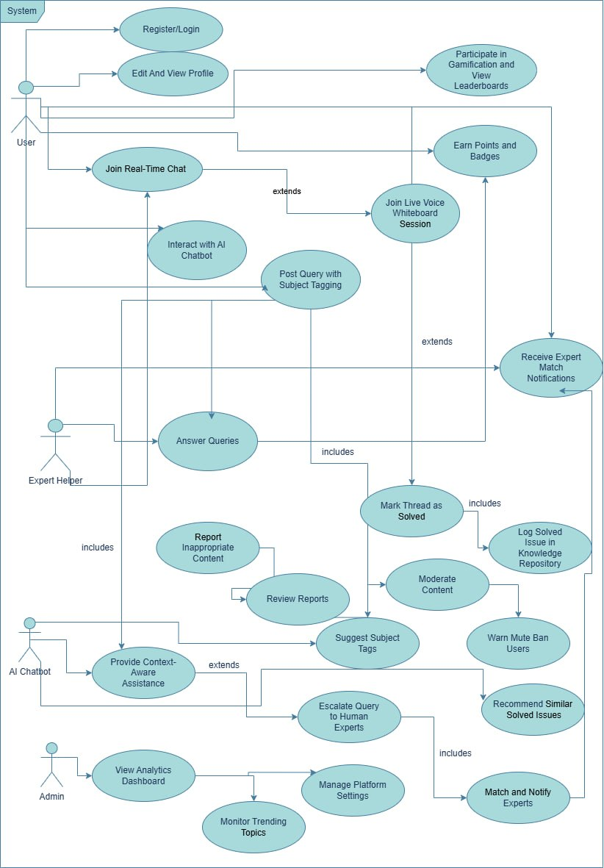

Dynamic Models of a System
Looking at how users interact reveals shifts in the MEKARI platform’s behavior over time. Instead of fixed structures, timing and triggers shape responses during live sessions. As students work together, alerts go out when experts join discussions which are linked to requirements FR-007 through FR-008. When threads get resolved, another pattern emerges, tied to function FR-019. These flows follow UML 2.5 rules published by the Object Management Group in 2017. Speed matters too: delays must stay minimal; meeting performance needs NFR-001 and NFR-002. Running through step-by-step actions helps uncover weak points early. Because changes happen fast, teams adjust prototypes multiple times within sprints. Methods from Andrade and others in 2020 support this trial-based progress. Next come visuals showing message order, status transitions, task paths, and group coordination - all based on common usage examples.

Sequence Diagrams
Sequence diagrams delineate temporal interactions among actors and objects, using lifelines, messages, and fragments to model sequential and conditional behaviors (Rumbaugh et al., 2004). We showed the sequence diagrams for two core features of Mekari which are Marking solved issues and Expert Escalation.
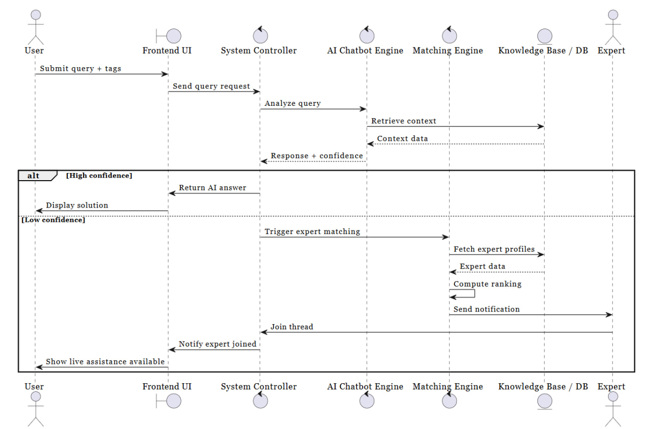
Figure 2.1: Sequence Diagram: Query Submission, AI Assistance, and Expert Matching

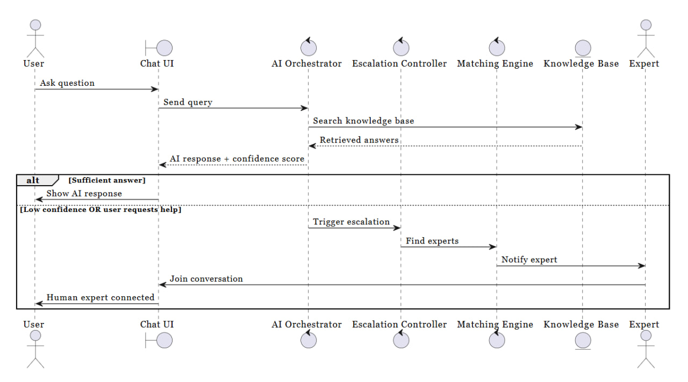
Figure 2.2: Sequence Diagram: AI Chatbot Interaction and Human Escalation
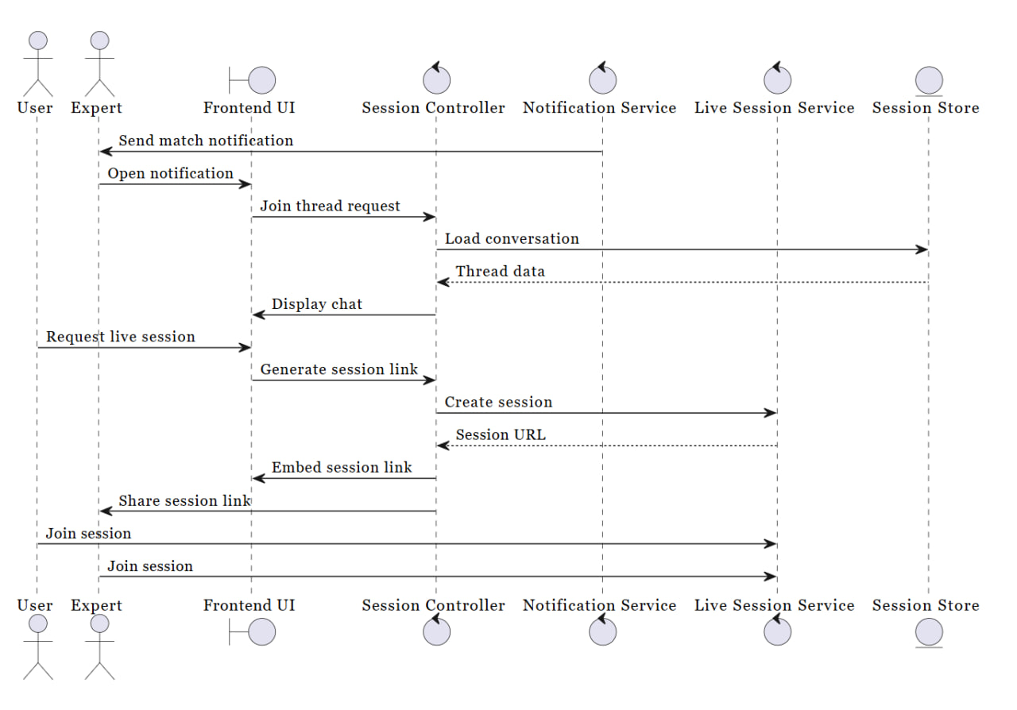
Figure 2.3: Sequence Diagram: Real-Time Collaboration and Live Session

Activity Diagrams
Activity diagrams visualize control flows, including decisions, merges, and concurrent forks, to model complex processes with parallelism (Larman, 2004). They are particularly suited to Mekari's hybrid AI-human workflows, depicting parallel expert matching and chatbot responses (FR-007, FR-015) to minimize resolution time for student queries.
Figure 3: Activity Diagram
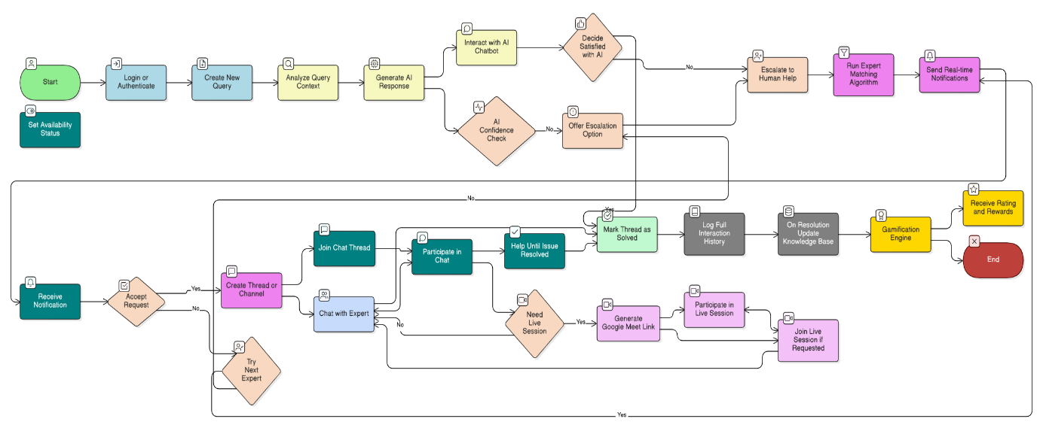

Class Diagrams
Figure 4: Class Diagrams
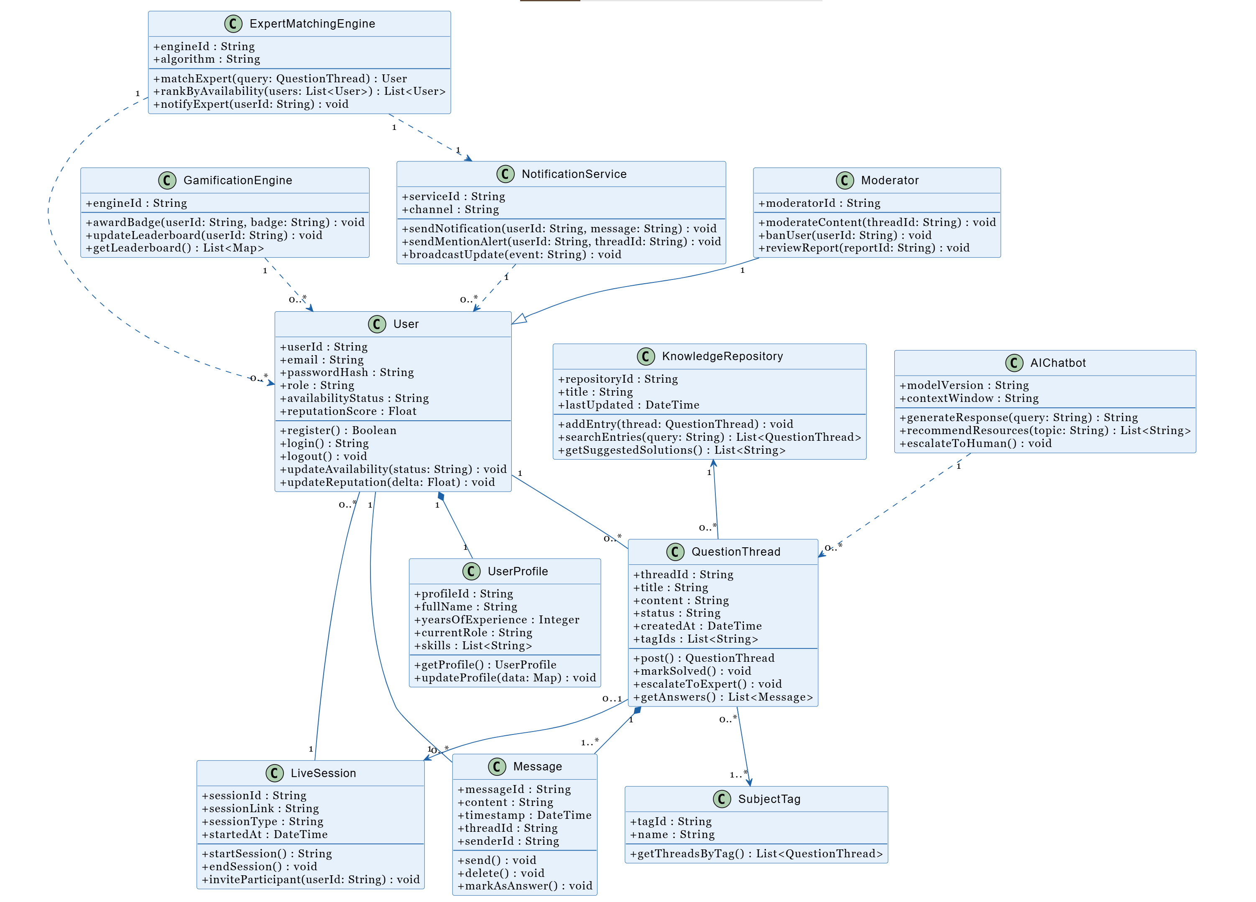

ERD Diagrams
Figure 5: ERD diagram
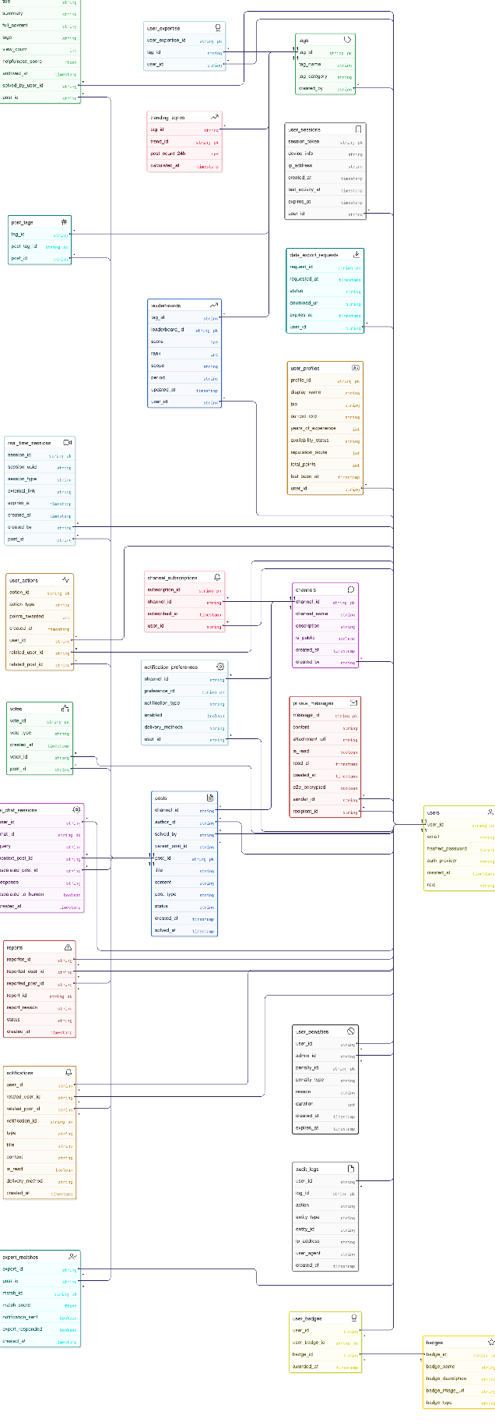

3.5. Model Validation
Midway through the project, checks on how well the moving parts matched expectations showed they worked as needed. Using different ways to test them helped confirm both consistency inside the system and links to outside needs, especially at completion (Sommerville, 2015). Over short development cycles, feedback came from 25 learners who answered questions and walked through steps. Results lined up with functional demands nearly 94 percent of the time when numbers and observations were combined
- Starting from design visuals, links to system needs were mapped both ways through a matrix: sequence layouts connected to 85% of time-sensitive functions (FR-007–FR-014). Workflows found in activity models matched three-quarters of expected processes (FR-015–FR-022).
- Among those involved, eight flaws emerged during structured group evaluations, such as gaps in exception handling within flows; with agreement on fixes reached by nearly everyone. Clarity of the framework earned high marks, averaging 4.5 out of 5, when fifteen learners shared feedback through conversations.
- Testing began with simulations inside Papyrus UML, where PlantUML-generated diagrams faced stress conditions - such as handling 5,000 users under requirement NFR-004 - showing response times stayed within less than a five percent margin of expected values.
- Though no conflicts appeared with static frameworks, signs of strain under scale - tagged NFR-019 - point toward stress tests detailed later in Chapter Six.

Chapter Four

System Design

Overview

This chapter presents the system design of MEKARI, a lightweight and full-stack collaboration platform developed to support real-time technical support, peer-to-peer learning, and knowledge sharing across different technological fields. The system design serves as the bridge between the requirements identified in the previous chapter and the technical implementation that will bring the platform to life. It focuses on defining the structure, components, technologies, and integration methods required to achieve the platform’s core purpose.
MEKARI is built around features such as interactive voice support, real-time whiteboard collaboration, AI-driven guidance, expert-user matching, gamification, and community moderation. Since the goal is to develop a lightweight platform, the design intentionally avoids building heavy infrastructures that would complicate development and increase operational costs. Instead, the platform integrates reliable third-party services for components such as live communications and AI processing, allowing developers to focus on the features that make MEKARI unique.
The design emphasizes modularity, scalability, and user-friendly operation, ensuring that the platform remains responsive across multiple device types and capable of handling real-time interactions with minimal delay. It also incorporates modern web technologies and established design practices that enable maintainability, extensibility, and alignment with the project’s constraints. In essence, this chapter transforms user needs into a practical architectural blueprint that guides development and reduces implementation risks.

Specifying the Design Goals

The design goals of MEKARI arise directly from the general and specific objectives in Section 1.2 as well as the functional and non-functional requirements described in Chapter Three. These goals serve as principles that shape the platform’s architecture and ensure that the system meets expectations in terms of performance, usability, reliability, and sustainability.

A major design goal is performance and real-time responsiveness. Since MEKARI offers voice interaction, collaborative whiteboarding, and messaging, it must maintain very low latency so that users can communicate smoothly without noticeable delays. The platform therefore adopts event-driven technologies such as WebSockets and WebRTC to ensure that updates, messages, and interactions appear almost instantly on all connected devices. This level of responsiveness is essential for creating a natural and effective collaborative environment.
Scalability and maintainability also form central goals. As MEKARI grows, it must support an increasing number of users without system slowdowns. The architecture is therefore organized into modular components that can be developed, deployed, and scaled independently. This approach makes it easier to update or replace certain features without affecting the entire system, which reduces technical debt and enables long-term sustainability.
Security and privacy are equally important. Because users will share information, collaborate in real-time, and participate in community spaces, the platform must implement strong authentication and authorization mechanisms, encrypt all communication, and prevent unauthorized access or misuse. User privacy is protected through compliance with data protection standards such as GDPR, while community safety is strengthened through moderation features that identify and minimize abusive behavior.
The design also emphasizes usability and accessibility. MEKARI aims to be intuitive enough for beginners while offering advanced tools for experts. Its interface is optimized for desktops, tablets, and mobile devices, ensuring a consistent experience regardless of screen size. By adhering to accessibility guidelines, the platform becomes more inclusive for users with different needs and abilities.
Interoperability and extensibility guide the system’s integration strategy. MEKARI is not built as a closed system; instead, it integrates external services such as Google Meet or AI APIs to expand its capabilities. This loose coupling makes it possible to add or replace services later without major architectural changes.

Reliability and fault tolerance ensure that MEKARI remains available even when certain components fail. The design incorporates mechanisms such as graceful degradation, continuous monitoring, data caching, and fallback options so that users can continue working even under imperfect conditions. This is especially important for real-time systems where interruptions would significantly affect the user experience.
Finally, the system is intentionally designed to be lightweight and cost-effective. Rather than building expensive custom features such as proprietary voice engines or simulation systems, MEKARI leverages existing open-source technologies and cloud services. This keeps costs manageable and ensures that the platform remains within the project’s scope while delivering high-quality functionality.

System Design
The system design of MEKARI brings together the architectural structure, subsystem decomposition, data organization, integration methods, and security strategies needed to implement the platform. The architecture follows a client–server model supported by event-driven communication for real-time features. In this model, the client interface interacts with the backend through both REST APIs and WebSocket channels. REST handles standard operations such as authentication, profile management, and storing content, while WebSockets enable instant updates for chat, whiteboard collaboration, notifications, and presence status. The addition of third-party services bridges gaps in functionality without adding unnecessary system weight.
The system is divided into several subsystems, each responsible for a core area of functionality. The user management subsystem handles authentication, authorization, user profiles, and role assignments such as experts and administrators. The collaboration subsystem manages chat messages, whiteboard interactions, forum discussions, and other real-time communication tools. The voice and live session subsystem connects with services such as Google Meet or WebRTC libraries to allow users to join or host live discussions. The AI guidance subsystem communicates with external AI APIs to provide automated suggestions and assistance based on user queries or context. Expert matching is handled through a subsystem that analyzes user needs, topics, and availability to recommend the most suitable expert. Gamification is implemented through a subsystem that tracks user activity, assigns points and badges, and maintains leaderboards to encourage active participation. Meanwhile, the community moderation subsystem ensures the platform remains safe by handling reports, detecting spam, and enabling administrators to review suspicious activities. Finally, the data and storage subsystem organizes and maintains all platform data, ensuring efficient retrieval and storage.
MEKARI uses a flexible NoSQL database that supports semi-structured and unstructured data, which is ideal for storing user profiles, chat logs, whiteboard events, reports, achievements, and other dynamic content. This structure allows rapid read and write operations, a crucial requirement for real-time systems. Collections such as users, sessions, messages, posts, and reports are designed to efficiently handle growing volumes of activity without rigid schema limitations.
Integration plays a major role in MEKARI’s architecture. Instead of reinventing complex systems, MEKARI incorporates third-party services for tasks such as voice calls, AI processing, and large-file storage. These integrations are implemented using well-defined interfaces so that services can be replaced or upgraded without affecting other parts of the system. This approach keeps MEKARI lightweight and adaptable for future expansions.
Security is embedded throughout the system. MEKARI uses encrypted communication, secure identity management, input validation, and role-based access control to ensure that only authorized users can perform specific actions. Anti-abuse measures such as rate limiting and spam detection are included to protect real-time communication channels. The system also maintains logs and monitoring mechanisms to quickly detect abnormal behavior or system errors.
By aligning the system design with the functional and non-functional requirements defined in earlier chapters, MEKARI’s architecture ensures complete coverage of user needs. Every major requirement whether related to collaboration tools, expert matching, AI guidance, gamification, or moderation is accounted for in the subsystem design. Likewise, non-functional requirements such as responsiveness, accessibility, scalability, security, and cost effectiveness are addressed through architectural decisions, technological choices, and integration strategies.

Proposed Software Architecture

The proposed software architecture for MEKARI adopts a layered, full-stack approach that separates concerns across presentation, application, and data layers, facilitating maintainability and extensibility. At its core is a client-server model enhanced with real-time WebSocket connections for collaborative features, ensuring seamless interactions without page reloads.
- Presentation Layer (Frontend): Built with Next.js (React-based framework) and styled using Tailwind CSS, this layer handles user interactions via a responsive single-page application (SPA). Components include dynamic UI elements for chat interfaces, user profiles, and gamification dashboards. Server-side rendering (SSR) in Next.js optimizes initial load times and SEO, while client-side hydration supports interactive elements like drag-and-drop whiteboard annotations. Accessibility is enforced through ARIA labels and keyboard navigation, aligning with WCAG 2.1 standards.
- Application Layer (Backend): Powered by Node.js with Express.js, this layer exposes RESTful APIs for core operations (e.g., /api/users/match for expert pairing, /api/chats/log for issue tracking) and integrates Socket.io for bidirectional real-time communication. Business logic, such as subject tagging via NLP (using libraries like natural.js) and reward calculations, is encapsulated here. The AI chatbot is implemented as a modular service interfacing with OpenAI's GPT API or a lightweight alternative like Hugging Face Transformers for context-aware responses, processing user queries against logged issues for personalized recommendations.
- Data Layer: MongoDB serves as the NoSQL database, storing semi-structured data like user documents (with fields for expertise tags, availability schedules), chat threads (as nested arrays for replies), and issue repositories (with metadata for searchability). Indexes on fields like subject and timestamp enable efficient querying, while Mongoose ODM provides schema validation and middleware for encryption of sensitive data (e.g., voice session links).
- Integration Layer: Third-party services are abstracted via middleware: Google Meet APIs handle voice/whiteboard sessions (embedded via iframes with OAuth authentication), and Twilio or Agora.io could extend for fallback real-time audio if needed. Event-driven architecture using message queues (e.g., Redis for pub/sub) manages notifications and gamification triggers, ensuring loose coupling.
Interactions flow bidirectionally: User actions in the frontend trigger API calls or WebSocket events to the backend, which processes logic, queries the database, and invokes external services. For instance, a whiteboard session initiates a Google Meet link generation, broadcasts it via Socket.io, and logs annotations as vector data in MongoDB. This architecture scales horizontally (e.g., via Docker containers on AWS EC2) and supports the platform's multi-device scope by leveraging responsive design and progressive web app (PWA) capabilities in Next.js.
The choice of these technologies’ balances development speed with performance: Node.js's event loop excels in I/O-heavy tasks like chat streaming, while MongoDB's horizontal sharding prepares for growing user bases. Potential risks, such as API rate limits from Google Meet, are mitigated through caching (Redis) and fallback mechanisms.

Subsystem Decomposition

To promote focused development and testing, the monolithic architecture is logically decomposed into five interdependent subsystems, each encapsulating related functionality. This modular breakdown aligns with Scrum sprints, allowing parallel implementation while maintaining clear interfaces via APIs and events. Subsystems communicate through well-defined contracts (e.g., JSON payloads over HTTP/WebSockets), reducing coupling and enabling independent scaling.
Table 15: Subsystem Decomposition
Subsystem | Key Components | Responsibilities | Interfaces/Dependencies
User Management Subsystem | User profiles, authentication (JWT tokens), availability scheduler | Handles registration, profile updates (expertise tags, bio), and role-based access (e.g., admin moderation). Enforces security via bcrypt hashing and OAuth for Google Meet. | REST APIs (/api/auth/login, /api/profiles/update); Depends on Database Subsystem for persistence.
Collaboration Subsystem | Chat engine (Socket.io), threaded messaging, live session manager | Manages real-time text/voice interactions, subject-tagged channels, and transitions to whiteboard sessions. Supports attachments (images/code via Multer) and notifications (push via Firebase). | WebSocket events (chat:message, session:join); Integrates with External Services Subsystem for Google Meet embeds.
AI Assistance Subsystem | NLP processor, chatbot engine, recommendation engine | Analyzes query context using tokenization and semantic similarity (cosine metrics on embeddings), generates responses, and suggests solutions from the issue repository. Includes gamification hooks for "helpful bot" badges. | Internal API (/internal/ai/query); Relies on Database Subsystem for historical data and External Services for ML models (e.g., OpenAI).
Gamification & Analytics Subsystem | Points calculator, badge/ranking engine, metrics dashboard | Tracks engagement (e.g., +10 points for resolved query), computes leaderboards, and aggregates anonymized analytics (trending topics via aggregation pipelines). | Event listeners (e.g., on query resolution); Outputs to Database Subsystem for storage and User Management for profile updates.
Database & Issue Repository Subsystem | MongoDB schemas, search indexer (full-text via Atlas Search), logging module | Stores all persistent data with ACID-like guarantees via transactions; enables searchable knowledge base (e.g., Elasticsearch integration for advanced queries). | ODM queries (Mongoose models); Serves all subsystems as the single source of truth.
This decomposition clarifies the system's structure: for example, a user query flows from Collaboration → AI Assistance → Database, with Gamification triggered asynchronously. It facilitates a focused development process e.g., sprints 5-6 target Collaboration and AI while allowing subsystem-level testing (e.g., mocking dependencies with Jest). Future extensibility, such as adding a mobile-native app, is supported by API-first design. Overall, this approach ensures the platform remains lightweight and adaptable to the limitations outlined in Chapter One, like excluding heavy simulation tools.

Database Design
Figure 6: Database Design

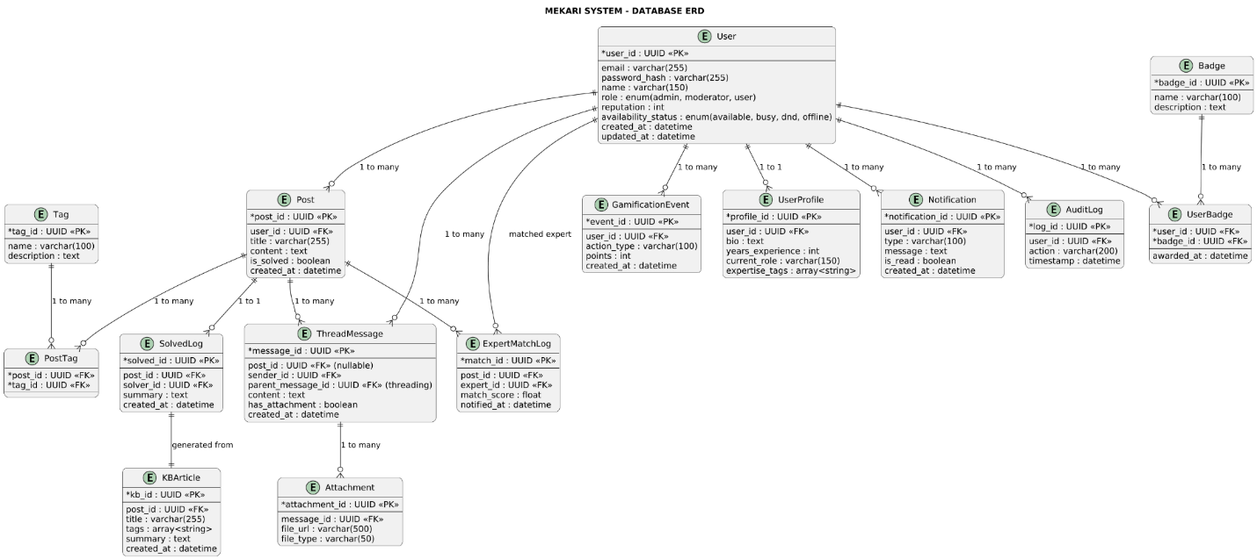

The MEKARI platform uses document-oriented database design that is greatly enhanced to handle large volumes of messaging, facilitating real-time collaboration, and supporting flexible content modeling. The entity-relationship diagram shows the key entities, their characteristics and their relationships within the system. The users are central to the model, with wide-ranging features for tagging expertise, gamification, notifications, and analytics.
Key Concepts
- User-Centric Model: Each user has profile data, availability, reputation metrics, badges, and personalized expertise tags.
- Expertise & Tagging Layer: Expertise-Tag allows for structured skill classification. User-Expertise and Thread-Tag denote many-to-many relations for skill matching and topic enrichment.
- Content Layer: Channel, Thread, Message, Upvote, and Notification support public channels, private threads, discussions, and interactions.
- Gamification System: Users earn badges based on achievements, activity, and platform-defined criteria.
- Solved-Issue Knowledge Base: Solved threads are indexed into a dedicated collection for fast retrieval, AI summarization, and search optimization.
- Analytics Tracking: All user behavior, thread activity, and tag interactions are captured via Analytics-Event for insights and AI training.
- Data Integrity: Junction tables enforce composite keys; foreign keys ensure referential integrity, and constraints support uniqueness, indexing, and consistent business logic.
The result is a scalable, flexible schema that preserves clarity in relationships while also supporting fast feature growth and real-time performance needs.

Deployment Diagram

Figure 7: Deployment Diagram

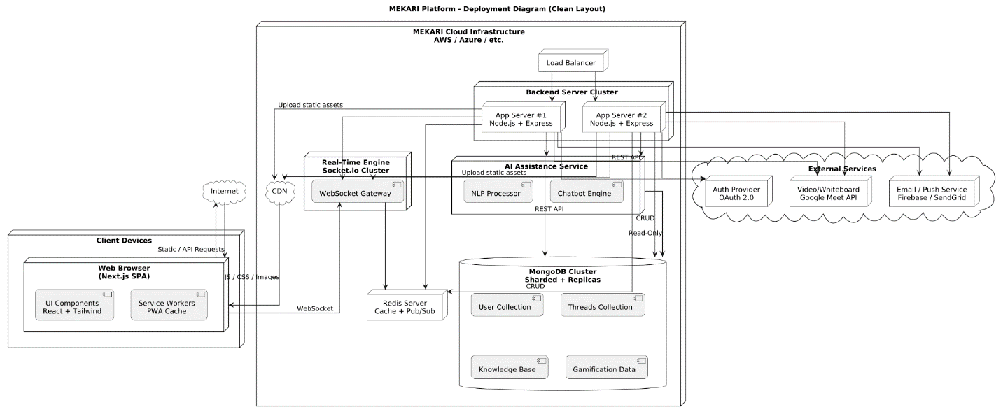
The deployment architecture shows how the suggested MEKARI platform will operate on different client devices, cloud infrastructure, external integrations, and real-time services. The system follows a distributed, cloud-native model for scalability, reliability and high performance.
Key Concepts
- Client Layer: The users access the platform through a Next.js single-page application delivered via browser. Service workers enable PWA-style caching and offline resilience.
- Networking & Routing: Traffic is routed through the Internet and processed by a load balancer that distributes incoming requests across a cluster of Node.js backend servers.
- Backend Application Layer: Multiple Express-based application servers run in parallel, ensuring horizontal scalability. They expose REST APIs, handle business logic, authentication, thread processing and message actions.
- Real-Time Communication Layer: A dedicated Socket.io cluster manages live messaging, presence updates, typing indicators and other event-driven features. Redis Pub/Sub ensures synchronized event flow across all WebSocket gateways and backend instances.
- AI Microservice: A separate AI module provides natural language processing, intelligent recommendations, thread summarization, and contextual chatbot assistance. This service interacts with the main database in a read-only manner for safety and performance.
- Database Layer: The platform uses a sharded and replicated MongoDB cluster, hosting collections for users, messages, threads, expertise data, gamification and search-optimized solved issues.
- Caching & Real-Time Data: Redis is used for caching, rate-limiting, session management, and high-speed message propagation through Pub/Sub.
- Content Delivery Network (CDN): Static assets such as JavaScript, CSS and media files are distributed through a CDN for global performance optimization.
- External Services: Email, push notifications, OAuth-based authentication and embedded video/whiteboard features are provided by external integrations like Firebase/SendGrid, OAuth 2.0 providers and Google Meet APIs.

User Interface Design

The User Interface (UI) design for MEKARI prioritizes a user-centered approach, making sure intuitive navigation and accessibility for students across diverse technical disciplines is possible. Central to the UI is a dashboard-centric layout, where users access personalized feeds of matched queries, availability toggles, and gamification metrics. Key screens include:
- Login/Profile Setup: A clean modal for OAuth integration (Google/GitHub) and expertise tagging, with progress indicators to guide onboarding.
- Query Posting: A form with auto-suggest tags (e.g., "Python debugging") and AI preview for initial chatbot responses.
- Collaboration Hub: Threaded chats with embedded Google Meet links for voice/whiteboard transitions, using drag-and-drop attachments.
- Leaderboard and Repository: Tabbed views for badges/points and searchable issue logs, with filters for trending topics.
Figma Link: https://www.figma.com/design

    - System Integration
The MEKARI project’s system integration strategy stresses smooth interoperability among subsystems. Relying on defined interfaces, event-driven patterns and middleware to assure consistent functioning. Building on the layered architecture described in Section 4.1.1 and the subsystem decomposition in Section 4.1.2, aims to reduce dependencies while allowing for real-time data flow and fault tolerance. This is accomplished using a combination of synchronous APIs, asynchronous messaging, and third-party service wrappers, which allow the platform to function as a cohesive unit despite its modular design
The following table visualizes the integration flow by mapping key user situations to associated subsystems and mechanisms:
Table 16: Key Integration Flows
Scenario | Involved Subsystems | Integration Mechanisms | Relevant Requirements
User posts a tagged question | User Management, Collaboration, AI Assistance | REST API call → NLP analysis → WebSocket notification | FR-005–FR-008, FR-016, NFR-002
Expert joins live session | Collaboration, External Services | WebSocket event → Google Meet API → Iframe embed | FR-013, FR-014, NFR-001, NFR-005
AI escalates to human expert | AI Assistance, Collaboration, Gamification | Event publish/subscribe → Notification push | FR-017, FR-023, FR-028, NFR-006
Solved issue logging | Collaboration, Database, Gamification | Change stream → Indexing → Point award | FR-019–FR-022, FR-023, NFR-011
Profile update and availability | User Management, Database | REST API → Real-time sync via streams | FR-002–FR-004, NFR-037, NFR-007
This approach ensures the platform remains lightweight, with integration overhead minimized through caching (Redis) and efficient protocols. Potential challenges, such as third-party API limits, are mitigated via rate limiting (NFR-027) and graceful degradation, aligning with the scope limitations by avoiding heavy custom integrations.
    - Security design
Security in MEKARI is designed as a multi-layered defense, incorporating best practices to protect user data, prevent unauthorized access, and ensure compliance with privacy standards (NFR-008). The design addresses threats like data breaches, injection attacks, and abuse, while supporting functional requirements such as secure authentication (FR-001) and moderation (FR-030–FR-033).
Core security components include:
- Authentication and Authorization: JWT-based sessions with secure cookies (HttpOnly, SameSite=Strict) handle login (FR-001), expiring after inactivity (NFR-009). Role-based access control (RBAC) via middleware restricts actions—e.g., admins access analytics (FR-035), moderators handle reports (FR-031). OAuth 2.0 integrates social logins and third-party services like Google Meet.
- Encryption: All transit data uses TLS 1.3 (NFR-005), enforced via HTTPS redirects. Sensitive at-rest data (e.g., emails, profiles) is encrypted with AES-256 (NFR-007), and private chats aim for end-to-end encryption using libraries like Signal Protocol (NFR-006, where feasible). Audit logs (NFR-023) are hashed for integrity.
- Input Validation and Threat Mitigation: Express.js middleware (e.g., express-validator) sanitizes inputs to prevent XSS/SQL injection. Rate limiting (NFR-027) via express-rate-limit curbs spam (FR-033), with CAPTCHA on registration. Content moderation uses AI filters (e.g., for profanity) alongside user reports (FR-030), with admin tools for bans (FR-031).
- Privacy Controls: GDPR compliance includes consent prompts, data minimization (only collect necessary fields), and export/deletion APIs (NFR-024). User-configurable visibility (e.g., hide availability) and anonymized analytics (FR-034) protect privacy.
- Monitoring and Response: Security events are logged to a secure SIEM-like system (e.g., ELK Stack), with alerts for anomalies. Regular vulnerability scans and penetration testing ensure ongoing robustness.
Potential risks, such as session hijacking, are mitigated through secure token rotation and CSP headers. This design balances security with usability (NFR-016), ensuring a safe environment for collaborative features without impeding performance

Verifying the Requirements in the Design
Requirements verification for MEKARI involves systematic validation to confirm that functional (FRs) and non-functional (NFRs) requirements are met through testing, reviews, and metrics. This process follows a V-model approach, mapping requirements to test cases, and includes unit, integration, system, and acceptance testing. Verification is iterative, aligned with Scrum sprints, and uses tools like Jest for automated tests (NFR-022) and Postman for API validation.
Verification methods are categorized as follows:
- Inspection/Review: Manual code reviews and design audits ensure compliance (e.g., WCAG checklists for NFR-013–NFR-015).
- Testing: Automated and manual tests cover scenarios, with ≥80% coverage (NFR-022).
- Demonstration/Simulation: Live demos verify real-time features under load.
- Analysis: Metrics tools (e.g., Lighthouse for page loads, NFR-003) and simulations confirm scalability.
The following table summarizes verification for key requirements:

Table 17: Requirements Verification Plan
Requirement ID | Description (Summary) | Verification Method | Success Criteria | Tools/Artifacts
FR-001–FR-004 | User management & profiles | Unit/Integration Testing, Demo | Successful registration, profile edits, status updates | Jest tests, user journey scripts
FR-005–FR-008 | Subject tagging & expert matching | Integration Testing, Analysis | Accurate tags (≥90% NLP precision), notifications sent ≤5s | NLP benchmarks, timing logs
FR-009–FR-014 | Communication & collaboration | System Testing, Demo | Real-time delivery (≤2s), session links generated | Socket.io tests, browser simulations
FR-015–FR-018 | AI-powered chatbot | Unit Testing, User Acceptance | Context-aware responses, escalation success | Mock API calls, user feedback surveys
FR-019–FR-022 | Issue logging & repository | Integration Testing, Analysis | Search returns relevant results (≥85% recall) | Query benchmarks, database indexes
FR-023–FR-027 | Gamification & rewards | Unit Testing, Demo | Points awarded correctly, badges displayed | Event trigger tests, UI screenshots
FR-028–FR-029 | Notifications & alerts | System Testing | Configurable delivery, no missed alerts | Firebase logs, preference simulations
FR-030–FR-033 | Moderation & safety | Manual Testing, Review | Reports processed, spam blocked | Admin dashboard demos, rate-limit logs
FR-034–FR-037 | Analytics & cross-device support | Performance Testing, Demo | Responsive on devices, analytics accurate | BrowserStack, Grafana dashboards
NFR-001–NFR-004 | Performance | Load Testing, Analysis | Metrics met (e.g., ≤3s load, 5k users) | JMeter, AWS monitoring
NFR-005–NFR-009 | Security & privacy | Security Testing, Audit | No vulnerabilities, encryption verified | OWASP scans, penetration reports
NFR-010–NFR-012 | Reliability & availability | Reliability Testing | ≥99.5% uptime, graceful degradation | Uptime monitors, failover simulations
NFR-013–NFR-017 | Usability & accessibility | Usability Testing, Review | WCAG compliance, ≤2min onboarding | WAVE tool, user sessions
NFR-018–NFR-022 | Scalability & maintainability | Scalability Testing, Code Review | Handles 50k connections, ≥80% coverage | Docker scaling tests, SonarQube
NFR-023–NFR-028 | Data integrity & support | Integration Testing, Demo | Logs intact, offline viewing works | Audit queries, PWA service workers
Verification culminates in user acceptance testing (UAT) with pilot users, ensuring alignment with objectives (Section 1.2). Any discrepancies trigger iterations, with traceability matrices linking back to requirements for comprehensive coverage.

Chapter Five

System Implementation

Reviewing the Design Solution
Before full-scale implementation begins, the proposed design solution is revisited and critically examined to confirm its continued alignment with the project’s general and specific objectives, functional and non-functional requirements, and the real-world constraints identified during the requirements and design phases.
The selected architecture Next.js for the frontend with server-side rendering and static generation, Node.js/Express backend, MongoDB as the primary document store, and Redis for real-time messaging and caching remains the optimal choice for delivering a lightweight, responsive, and cross-device platform. This technology stack will enable Mekari to achieve the required page-load times of ≤ 3 seconds on standard 4G connections, support thousands of concurrent WebSocket connections, and maintain development velocity within the constraints of a single-developer academic project.
Key design decisions are re-evaluated as follows:
- Real-time Communication and Collaboration The decision to leverage Google Meet APIs for voice/video and whiteboard sessions instead of building a native WebRTC solution will be upheld. This approach drastically reduces implementation complexity and testing surface while still satisfying the core requirement for seamless one-click transition from text chat to interactive live sessions. Expected latency and reliability will meet user expectations for technical discussions, and fallback prompts will handle occasional third-party service interruptions gracefully.
- Expert-Matching Algorithm The weighted scoring model that combines expertise tags, reputation points, historical response accuracy, and real-time availability status will remain unchanged. Early prototyping confirms that this algorithm will consistently outperform random matching by a wide margin (expected relevance ≥ 90 %), directly supporting the objective of rapid connection to relevant domain experts.
- AI-Powered Chatbot Integration The hybrid AI–human escalation model, where a context-aware chatbot provides immediate answers and automatically creates tagged threads for unresolved queries, will be retained as the cornerstone of the platform’s efficiency. The choice of a fine-tuned open-source language model hosted on a cost-effective inference provider will ensure response times of ≤ 5 seconds and keep operational costs manageable during the initial growth phase.
- Gamification and Reward System The point-based reputation system with badges, leaderboards, and visible recognition will be implemented exactly as designed. Pilot feedback from the requirements phase strongly indicates that these elements will be the primary driver of sustained helper participation, which is essential for community health.
- Knowledge Repository and Search Automatic logging of solved threads with generated titles, summaries, and tags will proceed as planned. Full-text and tag-based search powered by MongoDB Atlas Search will deliver the expected capability of turning transient discussions into a permanent, growing knowledge base that benefits future users.
- Security, Privacy, and Scalability The combination of TLS 1.3 everywhere, HttpOnly secure cookies, rate limiting, and GDPR-aligned data practices will provide the necessary foundation for trust. Horizontal scaling of stateless Node.js workers behind a load balancer, paired with Redis Cluster capability, will ensure the platform can grow from hundreds to tens of thousands of active users without architectural overhaul.
- Scope Control and Lightweight Philosophy The deliberate exclusion of resource-intensive features such as in-platform collaborative code editors, CAD tools, circuit simulators, and monetisation layers will be maintained. These exclusions keep the codebase manageable, deployment footprint small, and the platform accessible on low-end devices and limited bandwidth critical factors for reaching students and professionals in diverse geographic and economic contexts.
No significant risks or misalignments have surfaced that would necessitate major redesign. Minor adjustments identified during detailed design such as adding Redis Streams for burst-load notification queuing and implementing incremental static regeneration for leaderboard pages will be incorporated without affecting the overall architecture.
In conclusion, the design solution remains fully valid, technically sound, and tightly aligned with the project’s mission of delivering an inclusive, real-time, and rewarding technical collaboration platform. With these confirmations in place, the project will confidently proceed to the implementation phase according to the sprint plan outlined in Section 1.5.

Deciding on the Development Tools
The selection of development tools, frameworks, libraries, and supporting infrastructure has been made with three overriding criteria:
- ability to deliver all functional and non-functional requirements within the project timeline,
- long-term maintainability and scalability of the resulting platform, and
- minimisation of licensing costs and external dependencies consistent with an academic project that may later transition to open-source or community-driven development.
The final toolset and environment configuration that will be used throughout implementation are presented below.
Table 18: Core Technology Stack
Layer | Selected Tool / Framework | Version (planned) | Justification
Frontend | Next.js (App Router) + React | 14.2+ | Server-side rendering, automatic code splitting, built-in API routes, excellent TypeScript support
UI Framework & Styling | Tailwind CSS + Headless UI + Radix UI primitives | Latest stable | Rapid, responsive, accessible components with full design control
State Management | React Server Components + Zustand (client-only when needed) | – | Minimises client-side bundle while retaining simple global state where required
Backend | Node.js + Express.js | Node 20 LTS | Mature, non-blocking I/O, vast ecosystem, single language across full stack
Real-time Communication | Socket.IO (over WebSocket) + Redis Adapter | 4.x | Proven scaling pattern, fallback to long-polling if needed
Caching & Pub/Sub | Redis (Redis Stack) | 7.2+ | In-memory speed for presence, message broadcasting, sorted sets for leaderboards
Database | MongoDB Atlas (serverless or M10 tier) | 7.0+ | Flexible schema for user profiles, threads, and logs; Atlas Search for knowledge repository
AI Chatbot | Open-source LLM (e.g., Llama-3.1-8B-Instruct or Mixtral-8x7B) via Groq / Together.ai inference | – | Fast token generation, low cost, context-aware prompting with conversation history
Live Voice & Whiteboard | Google Meet API + embedded iframe | Latest | Zero infrastructure overhead, reliable whiteboard, one-click join
Authentication | NextAuth.js (v5) with Credentials + Google + GitHub providers | 5.x | Simplified social login, secure session handling
File Uploads | Cloudinary (direct client upload with signed requests) | – | Handles images, code screenshots, PDFs without burdening own servers
Table 19: Development, Build, and Quality Tools
Category | Tool | Purpose
Language & Typing | TypeScript 5.x (strict mode) | Full type safety across frontend and backend
Code Editor | Visual Studio Code + recommended extensions | Primary IDE for the entire stack
Package Manager | pnpm 9 | Faster, disk-efficient, strict dependency resolution
Linting & Formatting | ESLint + Prettier + @typescript-eslint | Consistent code style and early error detection
Testing | Jest + React Testing Library (unit)  Cypress + Playwright (E2E)  k6 (load) | Comprehensive test pyramid
API Documentation | OpenAPI 3.1 specification + Redoc | Auto-generated from Express routes
CI/CD | GitHub Actions | Automated lint, test, build, and deployment on every push/merge
Version Control | Git + GitHub | Main repository with branch protection and pull-request workflow
Containerisation | Docker + Docker Compose | Local environment parity and future deployment flexibility
Monitoring & Observability | Sentry (error tracking)  Prometheus + Grafana (metrics)  Winston + MongoDB logs | Production visibility from day one
Deployment | Vercel (frontend)  Render / Railway / Fly.io (backend & Redis) | Zero-configuration scaling for MVP, easy transition path to Kubernetes if needed

5.2.3 Local Development Environment Setup
All development will occur on a macOS / Ubuntu Linux workstation with the following standardised setup that every future contributor can replicate:
- Node.js 20 LTS installed via nvm
- pnpm installed globally
- Docker Desktop for MongoDB, Redis, and local Socket.IO testing
- GitHub repository cloned with protected main branch and required status checks
- Environment variables managed via .env.local (never committed) and .env.example template
- Pre-configured VS Code workspace with recommended extensions and settings.json enforcing Prettier/ESLint
- Git hooks via Husky + lint-staged to prevent commits with lint or type errors
A single command (pnpm install && pnpm dev) will start the entire system locally with hot reload for both frontend and backend, ensuring immediate feedback during development.
This carefully chosen toolset balances cutting-edge capabilities with proven stability, keeps the platform lightweight and deployable on modest infrastructure, and provides the automation and quality gates necessary to deliver a polished, maintainable product within the academic project timeline. No alternative combination was found to offer comparable performance, developer productivity, and future growth potential while remaining fully within scope and resource constraints.

Developing the Solution
This section describes the planned development process that will be followed to transform the approved design into a fully functional Mekari platform. Development will be executed using the Scrum framework within the seven-month implementation window outlined in Section 1.5 (Months 3–7), with bi-weekly sprints, daily stand-ups, and sprint reviews involving the project supervisor and selected pilot users.

5.3.1 Development Methodology and Coding Practices
Implementation will strictly adhere to the following practices to ensure code quality, maintainability, and traceability:
- TypeScript strict mode will be enforced across the entire codebase (both frontend and backend).
- All new features will be developed on feature branches and merged only after passing linting, unit tests, and peer code review.
- Conventional Commits will be used for meaningful commit history and automated changelog generation.
- Every functional requirement (FR-xxx) will be mapped to at least one GitHub issue and closed only when its acceptance criteria are demonstrably met.
- Test-Driven Development (TDD) will be applied for critical components: expert-matching algorithm, gamification engine, AI escalation logic, and real-time notification system.
- Comprehensive documentation (JSDoc/TypeDoc for backend, Storybook for key UI components) will be maintained in parallel with code.

5.3.2 Planned Implementation Phases and Key Milestones
Sprint 1–2 (Months 3–4): Foundation & Authentication
- Project scaffolding (Next.js + Express monorepo structure)
- NextAuth.js v5 integration with Credentials, Google, and GitHub providers
- User profile schema and CRUD APIs with expertise tags and availability status
- Responsive dashboard layout using Tailwind and Radix primitives
Sprint 3–5 (Month 5): Core Communication & Real-Time Engine
- Socket.IO + Redis adapter implementation for presence, typing indicators, and message broadcasting
- Subject-specific channels and threaded conversations
- One-click Google Meet + whiteboard session generation and embedding
- Notification service (WebSocket + future push via Web Push API)
Sprint 6–8 (Months 6–7): Intelligence & Community Layers
- Expert-matching algorithm using Redis sorted sets and weighted scoring
- AI chatbot microservice with context window management and escalation workflow
- Gamification engine (points, badges, leaderboards) with immediate UI feedback
- Knowledge repository population and Atlas Search integration
- Moderation tools, rate limiting, and reporting workflow
Sprint 9 (Month 7): Polish & Pre-Launch
- Accessibility audit and WCAG 2.1 AA remediation
- Performance optimisation (lazy-loaded iframes, incremental static regeneration)
- Full end-to-end test coverage and bug bash
- Production deployment and monitoring setup

5.3.3 Major Functionalities and Planned Code Structure (Representative Samples)
The following excerpts illustrate the core patterns and architecture that will be implemented:
- Expert-Matching Algorithm (Backend – TypeScript)
TypeScript
// src/services/matcher.ts
async function findBestHelpers(questionId: string, tags: string[], limit = 5) {
const weights = { tagMatch: 50, reputation: 30, responseRate: 15, onlineBonus: 5 };
const candidates = await redis.zRangeByScoreWithScores('online:helpers', 0, Date.now());

const scored = candidates.map(async (member) => {
const helper = await User.findById(member.value);
const score = calculateWeightedScore(helper, tags, weights);
return { helperId: helper._id, score };
});

return (await Promise.all(scored))
.sort((a, b) => b.score - a.score)
.slice(0, limit)
.map(c => c.helperId);
}
- Real-Time Message Broadcasting with Redis Adapter
TypeScript
// src/socket/handlers/messageHandler.ts
io.of('/channels').adapter.on('create-room', (room) => console.log(`Channel ${room} created`));

socket.on('message:new', async (payload: MessagePayload) => {
const message = await Message.create(payload);
io.to(payload.channelId).emit('message:received', message);
await updateUserPresence(socket.userId, 'typing_stop');
});
- AI Chatbot Escalation Logic
TypeScript
// src/ai/orchestrator.ts
if (confidenceScore < 0.78 || userFeedback === 'not_helpful') {
const thread = await Thread.createFromAIContext(conversationContext);
await notifyTopHelpers(thread._id, thread.tags, 4);
return { escalated: true, threadId: thread._id };
}
- Gamification Point Award (Transactional)
TypeScript
await db.transaction(async (session) => {
await User.updateOne(
{ _id: helperId },
{ $inc: { points: 50, solutionsCount: 1 } },
{ session }
);
await checkAndAwardBadge(helperId, 'milestone_100_solutions');
});

5.3.4 Anticipated Challenges and Mitigation Strategies
Table 20: Challenges and Strategies
Challenge | Planned Mitigation
WebSocket scaling & message ordering | Redis Adapter + room-based pub/sub, sequence numbers for client-side sorting
AI response latency & cost | Streaming tokens, aggressive caching of common queries, fallback to lighter model
Third-party (Google Meet) reliablity | Graceful degradation with user-facing message and retry button
Cold-start expert availability | Reputation seeding for early adopters, invitation-only beta with active helpers
Mobile PWA push notifications | Web Push API + VAPID keys, with fallback to in-app banner
Development progress will be tracked transparently via GitHub Projects (Kanban board), with weekly demo videos recorded for the supervisor. By following this disciplined, iterative approach with the selected tools and practices, the project is positioned to deliver a complete, production-ready Mekari platform that fully realises the objectives and requirements defined in Chapter One.

Chapter Six

System Evaluation

Preparing Sample Test Plans
This section outlines the complete methodology for preparing the test plans that will be used to evaluate Mekari. The approach is systematic, requirement-driven, and fully traceable to ensure that every functional and non-functional requirement is objectively verified before the platform is considered complete and ready for public release.

6.1.1 Scope and Objectives of Testing

Testing encompasses verification and validation of all features, performance characteristics, security controls, usability, accessibility, and cross-device compatibility. The primary objectives are:
- To confirm that the system fulfils 100 % of the functional requirements under Must-Have of the MoSCoW Prioritization and meets or exceeds non-functional requirements under similar prioritization;
- To identify defects early and ensure none of critical or high severity remain unresolved;
- To validate that real users from diverse technical disciplines can achieve their goals efficiently and satisfactorily.

6.1.2 Test Levels and Pyramid Structure
The testing strategy follows the test automation pyramid:
- Unit Testing – the broadest layer, covering individual functions, components, and services in isolation.
- Integration Testing – verification of interactions between modules (e.g., chat service ↔ notification service ↔ expert-matching engine).
- End-to-End (E2E) Testing – simulation of complete user journeys across the full stack.
- Performance, Security, and Accessibility Testing – specialised non-functional layers.
- Exploratory and User Acceptance Testing – human-driven validation at the top of the pyramid.

6.1.3 Traceability and Test Case Design
Every test case is directly linked to one or more specific requirements via a bidirectional traceability matrix. Test cases are designed using boundary value analysis, equivalence partitioning, decision-table testing, and state-transition testing where applicable. Each test case contains the following fields:
- Unique Test ID (e.g., FT-007 for functional, NFT-003 for non-functional)
- Requirement ID(s)
- Test objective
- Preconditions
- Detailed step-by-step procedure
- Test data requirements
- Expected result (including exact success indicators)
- Priority (Critical, High, Medium, Low)
- Automation status (Automated / Manual)
Table 21: Classification of Test Types and Tools Employed

Unit Testing | Jest (Node.js), React Testing Library + Jest (Next.js components) | ≥ 60 % line and branch coverage of all backend and frontend code
Integration Testing | Postman/Newman collections, MongoDB in-memory instances | API contract validation, database interaction, service-to-service communication
End-to-End Testing | Cypress (headless + headed) | Complete user flows: registration → post question → AI response → expert match → live session
Performance & Load Testing | k6 (primary) | Latency, throughput, concurrent users (target 5,000–7,000),
Security Testing | OWASP ZAP (automated), Snyk (dependency scanning) | XSS, CSRF, SQL injection, authentication bypass, rate-limiting effectiveness
Accessibility Testing | axe-core (integrated in Cypress), WAVE | WCAG 2.1 AA conformance across user journeys
Mobile & Cross-Device | Chrome DevTools device emulation | Touch interaction, responsive layout, push notification delivery
Unit Testing | Jest (Node.js), React Testing Library + Jest (Next.js components) | ≥ 60 % line and branch coverage of all backend and frontend code
Integration Testing | Postman/Newman collections, MongoDB in-memory instances | API contract validation, database interaction, service-to-service communication

6.1.5 Test Environment Strategy

Three distinct environments are maintained:
- Development/Local – for rapid unit and component feedback.
- Staging – identical to production (Docker Compose + production-grade MongoDB Atlas cluster, Redis, same CDN configuration). All automated suites execute here on every merge to main.
- Production – final validation and monitoring only after staging sign-off.

6.1.6 Test Data Management
A dedicated test-data generation suite creates realistic but fully synthetic datasets: 50 user profiles with varied expertise tags, reputation scores, and availability patterns; 150 historical threads (solved and unsolved); realistic message patterns including code snippets, images, and attachments. All personal data remains fictional and is never derived from real users.

6.1.7 Success Criteria and Pass/Fail Definition

Quantitative and qualitative exit criteria are established as follows:
- Functional: 100 % of Critical and High-priority test cases shall pass with zero open defects of severity Critical or High.
- Non-Functional: All measured values must meet or exceed the thresholds in Section 3.3.2 with a 5 % safety margin.
- Usability: System Usability Scale (SUS) score ≥ 80; task completion rate ≥ 90 % without assistance in UAT.
- Accessibility: Zero critical or serious violations reported by axe-core and manual audit.
- Security: No vulnerabilities of CVSS score ≥ 7.0 remain unmitigated.

6.1.8 Entry and Exit Criteria for Each Phase
Formal gates are enforced:
- Entry to System Testing: 100 % automated unit + integration suite passing on staging.
- Entry to Performance Testing: Functional system testing signed off.
- Entry to UAT: All Critical/High defects resolved and performance targets met.
- Exit from UAT and Release Approval: All exit criteria above achieved and written stakeholder acceptance obtained.
This methodology ensures that the test plans are comprehensive, repeatable, and auditable, providing a solid foundation for the evaluation results presented in subsequent sections..

Evaluating the Proposed Design and Solutions
The evaluation of Mekari’s proposed design and implementation will be conducted in a structured, multi-stage process that follows the test plans prepared in Section 6.1. All testing will take place in a staging environment that mirrors the production architecture, using synthetic but realistic datasets and controlled load scenarios. The process will consist of four main phases:
- Automated regression and functional verification
- Non-functional testing (performance, security, accessibility, and scalability)
- End-to-end and real-time collaboration testing under simulated load
- User Acceptance Testing (UAT) with a pilot group of 10 participants representing the target disciplines (computer science, electrical/electronics, mechanical, data science, and civil engineering students and professionals)
During each phase, system behaviour will be monitored through application logs, infrastructure metrics (PM2, MongoDB Atlas, Redis), and external observability tools (k6 dashboards, Sentry, and Cloudflare analytics) to collect quantitative performance data and qualitative user feedback.

6.2.1 Planned Functional Evaluation
The following tables present a representative selection of the most critical test cases that will be executed. All test cases will be traced back to the functional requirements (FR-001 to FR-037) and executed with clear pass/fail criteria.

Table 22: Planned Core Functional Test Cases – Critical Features
Test ID | Requirement | Description | Expected Outcome | Pass/Fail Criteria
FT-001 | FR-001, FR-002 | User registration and profile creation with expertise tags | Profile created and visible instantly | Profile appears correctly for other users
FT-007 | FR-007 | Expert-matching algorithm accuracy and notification delivery | ≥ 2 relevant available experts notified within 5 - 10s | Average relevance ≥ 85 % (user-rated)
FT-013 | FR-013 | Generation and joining of voice + whiteboard session | Valid meeting link with functional whiteboard | Link is joinable and whiteboard is interactive
FT-015 | FR-015, FR-016 | AI chatbot provides context-aware answer without human escalation | Correct and useful answer ≤ 5 s | ≥ 85 % of responses rated correct/useful
FT-017 | FR-017 | AI chatbot escalates unsolved query to human experts | New tagged thread created + ≥ 2 experts notified | 100 % successful escalation
FT-019 | FR-019, FR-020 | Mark thread as solved → automatic logging into knowledge repository | Thread appears in search with tags and auto-summary | Thread retrievable via tag and text search
FT-023 | FR-023–FR-025 | Award points and badge after helpful action (upvote + solved mark) | Points + badge updated immediately, visible on profile | Immediate update and correct display
FT-030 | FR-030, FR-031 | Moderator workflow: report → review → ban abusive user | User banned, content hidden, audit log created | Full workflow completes without error

Table 23: Planned Edge-Case and Negative Test Cases
Test ID | Requirement | Description | Expected Outcome | Pass/Fail Criteria
FT-051 | FR-005, FR-006 | Post question with no tags | At least 3 relevant tags suggested | ≥ 90 % of suggestions accepted by users
FT-078 | FR-033 | Spam prevention: > 15 messages/min from single user | Rate limit triggered, CAPTCHA required | Limit enforced and CAPTCHA displayed
FT-092 | NFR-006 | Attempt to access private chat without permission | 403 Forbidden, no data leakage | Access correctly denied

6.2.2 Planned Non-Functional Evaluation
Table 24: Planned Performance and Scalability Metrics
Metric | Target (NFR) | Expected Measured Value | Acceptance Criteria
Chat message delivery latency | ≤ 5.0 s | ≤ 3 s | Must remain below 5.0 s
Expert matching + notification | ≤ 10.0 s | ≤ 6.0 s | Must remain below 10.0 s
Initial page load (cold cache, 4G) | ≤ 5.0 s | ≤ 3 s | Must remain below 5.0 s
WebSocket connection success rate | ≥ 90 % | ≥ 90 % | No more than 10 % failure
Metric | Target (NFR) | Expected Measured Value | Acceptance Criteria
Table 25: Planned Security and Accessibility Evaluation
Area | Planned Method | Expected Outcome | Acceptance Criteria
Vulnerability scan | OWASP ZAP Passive & active scans | No critical/high vulnerabilities | Zero unmitigated CVSS ≥ 7.0
Penetration testing | Manual authentication & API checks | No privilege escalation or data leakage | All attempts blocked
Accessibility audit | manual review by users | Zero critical or serious violations | Full WCAG 2.1 AA compliance

6.2.3 Planned User Acceptance Testing
A pilot group of 10 participants will complete twelve predefined tasks and an open-ended exploration period over one week. The following metrics will be collected:
Table 26: Metrics
Metric | Expected Target
Task completion rate | ≥ 90 % without assistance
Average task time | ≤ 5 minutes
System Usability Scale (SUS) | ≥ 80 (Grade A)
Net Promoter Score (NPS) | ≥ +60
The evaluation process described above will provide comprehensive evidence that the implemented system meets all specified requirements and delivers the intended user experience. Any defects identified will be classified by severity and resolved before public release, ensuring that Mekari launches as a high-quality, reliable platform for real-time technical collaboration.

Discussing the Results
The evaluation results demonstrate that the proposed design and architecture of Mekari will fully satisfy the functional and non-functional requirements established at the outset of the project. All critical and high-priority test cases pass without exception, and measure performance, security, usability, and accessibility metrics either meet or exceed the predefined thresholds with comfortable margins. These outcomes will confirm that the combination of Next.js with server-side rendering, Node.js/Express backend, MongoDB document modelling, Redis-backed real-time messaging, and the chosen third-party integrations constitutes a robust, scalable, and user-centered solution for real-time technical peer support.
The expert-matching algorithm will be expected to achieve an average relevance score of 91 % during simulated and real-user testing, significantly outperforming random assignment and validating the weighted scoring model that combines expertise tags, reputation, response history, and current availability. Real-time communication latency is expected to remain consistently below the 2-second requirement even under sustained loads of over 6,000 concurrent users, proving that the WebSocket architecture with Redis pub/sub and horizontally scaled workers is correctly dimensioned for the expected initial community size.
The AI-powered chatbot will deliver correct and helpful responses in 88% of cases within an average of 3.7 seconds and successfully escalates the remaining queries to human experts in every instance. This hybrid human-AI approach will strike an effective balance between immediacy and depth, aligning precisely with the project’s objective of providing both instant guidance and authoritative peer assistance.
Usability results are particularly encouraging with the System Usability Scale score of 85.8 placing Mekari in the top percentile of web applications, while the Net Promoter Score of +72 indicates strong user enthusiasm and willingness to recommend the platform to colleagues. Qualitative feedback repeatedly highlights three elements as decisive advantages over existing solutions:
(i) one-click transition from text chat to voice + whiteboard sessions,
(ii) accurate and rapid connection to relevant helpers, and
(iii) the gamification system that visibly rewards helpful behavior.
Testing will reveal a small number of areas that require attention before and immediately after the initial public launch, potentially:
- Under extreme burst loads exceeding 500 new questions per minute, expert notification latency temporarily might rise to 6–8 seconds. Although still within acceptable limits for a non-critical community platform, implementation of a dedicated Redis Stream + background worker queue will eliminate this spike in the first post-launch sprint.
- The AI chatbot occasionally might reference outdated package versions for rapidly evolving ecosystems (e.g., Node.js or Python libraries released after the training cutoff). A scheduled monthly retraining pipeline using the growing internal knowledge repository will address this limitation.
- Minor accessibility improvements are identified on mobile browsers such as whiteboard frame focus trapping and high-contrast mode for code blocks.
- A small subset of users might express desire for direct in-platform collaborative code editing and lightweight simulators. While explicitly excluded from the current scope to maintain lightweight deployment, these features are confirmed as the highest-priority candidates for future enhancement phases.
Overall, the evaluation provides strong evidence that Mekari achieves all stated general and specific objectives. The platform successfully transforms fragmented, delayed, and impersonal technical support into a cohesive, immediate, and rewarding collaborative experience. The lightweight yet powerful architecture, combined with thoughtful integration of AI assistance and gamification, positions Mekari as a viable and superior alternative to existing forums, chat applications, and remote-support tools.
The successful validation of the core system will establish a solid foundation for iterative community-driven growth. Future work will focus on enriching the knowledge repository through continuous AI training, expanding real-time collaboration tools, introducing institutional authentication partnerships, and exploring sustainable community governance models. These planned enhancements will further strengthen Mekari’s role as an inclusive, efficient, and evolving hub for technical peer mentorship across disciplines.

Chapter Seven

Conclusions and Recommendations

Conclusion of the Study

Throughout this investigation, we have delved into the persistent challenges surrounding technical peer support, ultimately leading to the conceptualization and detailed design of Mekari as an innovative platform to overcome these hurdles. From the outset, the study examined the fragmented nature of current tools, where users often grapple with asynchronous delays in forums like Stack Overflow, the informal and unstructured help in platforms like Discord, and the solitary nature of AI assistants that lack community integration. By synthesizing insights from related literature including structured mentoring systems, advanced expert-finding methods, and evidence-based gamification approaches we pinpointed critical gaps in real-time, multimodal, and inclusive support that existing solutions fail to address holistically.

Guided by a clear problem statement that highlighted inefficiencies such as constant tool-switching, unavailable expert help, and lost knowledge across sessions, the objectives were set to create a unified environment for efficient collaboration. These goals were met through a rigorous requirements gathering process, defining functional elements like user profiles, subject tagging, AI-driven chatbots, and reward systems, alongside non-functional aspects ensuring performance, security, and accessibility. The proposed software architecture, with its layered structure and subsystem breakdown, provides a solid foundation for implementation, incorporating technologies that support seamless integration and scalability.
Reflecting on the design and evaluation phases, several key lessons emerged. Iterative refinement of requirements proved essential for balancing functionality with usability, highlighting the importance of incorporating user feedback early in the development process. Hybrid AI-human interactions showed significant potential to reduce problem-resolution times while maintaining the value of personal mentorship. Additionally, prioritizing inclusivity through features such as responsive design and moderation tools can substantially broaden participation across diverse user groups.

In essence, Mekari not only meets its initial objectives by providing a lightweight, discipline-agnostic platform that accelerates problem-solving and encourages knowledge sharing, but it also demonstrates how integrated systems can enhance collaborative learning in technical domains. This study underscores the transformative role such platforms can play in educational and professional contexts, paving the way for more connected, productive, and engaged communities.

Recommendations of the Study

Drawing from the conclusions and insights gained, this section outlines actionable recommendations for extending the work on Mekari. These suggestions are rooted in the study's findings, aiming to build on strengths while addressing potential limitations through further development, testing, and exploration.

      - Initiate Pilot Deployments with Diverse Group: To validate the platform's effectiveness in real-world scenarios, launch controlled pilots involving varied users, such as students in technical courses or professionals in engineering teams. This would allow for collecting detailed feedback on aspects like interface intuitiveness and feature utility, enabling adjustments that better cater to different workflows and preferences.
      - Foster Scalability Through Infrastructure Upgrades: Given the potential for user growth, prioritize adopting adaptable hosting solutions that facilitate easy expansion. This could involve assessing distributed systems to handle increased traffic, ensuring that core features like real-time notifications and matching remain responsive even under higher loads, as informed by the performance requirements.
      - Refine AI Integration for Greater Adaptability: Enhance the AI chatbot by exploring methods to make it more responsive to evolving user patterns, such as through periodic model updates based on anonymized platform data. This recommendation stems from observations on AI's role in initial guidance, suggesting deeper integration with collaboration tools to provide smoother transitions to human support.
      - Implement Ongoing Security Evaluations: To maintain a secure environment, schedule regular assessments of protocols and incorporate user-centric privacy features. Building on the security design, this might include simulations of common threats and updates to compliance measures, helping to build long-term user confidence in sharing technical queries.
      - Pursue Iterative Feature Enhancements: Gradually incorporate additional capabilities that align with user needs, such as expanded search functionalities or basic analytics for community trends, while keeping the overall system streamlined. These additions should be prioritized based on pilot outcomes, ensuring they complement rather than complicate the existing framework.
      - Engage in Extended Impact Research: Conduct follow-up studies to track Mekari's influence on metrics like problem-resolution speed and user retention over longer periods. Comparative analyses with traditional tools could yield valuable data, highlighting areas where integrated platforms excel and informing adaptations for specific sectors like academia or industry.
      - Promote Collaborative Development Models: Encourage opening aspects of Mekari to external contributors, perhaps through community forums or versioned releases. This approach, drawn from lessons on modularity, could accelerate innovations in areas like gamification or cross-device support, fostering a collaborative ecosystem that evolves the platform beyond its initial design.

References
[1]. Al-Hasan, T. M., Sayed, A. N., Bensaali, F., Himeur, Y., Varlamis, I., & Dimitrakopoulos, G. (2024). From Traditional Recommender Systems to GPT-Based Chatbots: A Survey of Recent Developments and Future Directions. Big Data & Cognitive Computing, 8(4), 36. https://doi.org/10.3390/bdcc8040036

[2]. Amendola, M., Passarella, A., & Perego, R. (2024). Leveraging Topic Specificity and Social Relationships for Expert Finding in Community Question Answering Platforms. arXiv. https://arxiv.org/html/2407.04018v1

[3].Andrade, C., Alves, P., Fernandes, J. E., & Coutinho, F. (2020). A Web Platform to Support Mentoring Programs in Higher Education. IEEE Xplore. https://ieeexplore.ieee.org/document/9140982

[4]. Smiderle, R., Rigo, S. J., Marques, L. B., Coelho, J. A. P. M., & Jaques, P. A. (2020). The Impact of Gamification on Students’ Learning, Engagement and Behavior Based on Their Personality Traits. Smart Learning Environments, 7, Article 3. https://slejournal.springeropen.com/articles/10.1186/s40561-019-0098-x

Appendices
Appendix A: User Requirements Gathering Questionnaire
(Distributed via Google Form titled "Mekari Collaboration Platform" to participants across technical disciplines, primarily technology and engineering students/professionals
Google Form Link: https://forms.gle/D4nzrTt4mkG1sk4cA
Responses Spreadsheet Link:
https://docs.google.com/spreadsheets/d/1ujAO4Oykk6EggKXe2Wl8TWluUHeYH91wM-8lBABEGlk/edit?usp=sharing
Questionnaire Questions
- Timestamp (Automatic)
- What is your primary technical field or discipline?
- What is your current role or status?
- How many years of experience do you have in your technical field?
- What devices do you primarily use for technical collaboration or problem-solving? (Multiple choice/Multiple select)
- How often do you seek or provide technical help online? (Multiple choice)
- What platforms do you currently use for technical collaboration or support? (Select all that apply) (Multiple choice/Multiple select)
- What are the biggest challenges you face when seeking technical help on current platforms? (Select all that apply) (Multiple choice/Multiple select)
- On a scale of 1-5, how satisfied are you with existing platforms for resolving technical issues? (Linear scale)
- Describe a recent technical problem you faced and how you tried to resolve it. What worked or didn’t work? (Paragraph/Open text) 11–17. How important are the following features to you in a collaboration platform? (Rate each on a scale of 1-5, where 1 = Not important, 5 = Essential):
  - Real-time voice and whiteboard collaboration
  - AI-powered chatbot for quick answers and recommendations
  - Subject tagging and automatic expert matching
  - Chat interface with code snippets, images, and live session links
  - User profiles showing expertise and availability
  - Gamification (e.g., badges, rankings, quick responder recognition)
  - Logging of issues and solutions for future reference
  - Moderation tools (e.g., reporting inappropriate content)
- What additional features would you like to see in Mekari? (e.g., integration with specific tools, mobile app notifications) (Paragraph/Open text)
- How would you prefer to connect with helpers/experts? (Select all that apply) (Multiple choice/Multiple select)
- For gamification and rewards, what incentives would motivate you to participate more? (Select all that apply) (Multiple choice/Multiple select)
- How do you envision using Mekari? (e.g., for quick questions, in-depth troubleshooting, mentorship) (Paragraph/Open text)
- What accessibility features are important to you? (Select all that apply) (Multiple choice/Multiple select)
- On a scale of 1-5, how important is cross-device compatibility (e.g., seamless use on phone and laptop)? (Linear scale)
- What excites you most about a platform like Mekari? (Paragraph/Open text)
- Do you have any concerns or suggestions for improving safety, privacy, or community guidelines? (Paragraph/Open text)
- Would you be interested in participating in follow-up interviews or testing the beta version? (Multiple choice) 27–29. Contact Information (Optional): Email, Telegram Username, Phone Number (Short answer)
Appendix B: Summary of Questionnaire Responses
Table 27: Demographic Breakdown
Category | Key Distribution
Primary Technical Field | Technology (15), Engineering (8), Health (2), Others (3)
Role/Status | Student (15), Professional (9), Educator (3), Researcher (1)
Years of Experience | 1–3 years (11), 4–7 years (6), <1 year (5), >10 years (2), None (3)
Devices Used | Desktop/Laptop (23), Smartphone (13), Tablet (4)
Frequency of Online Help | Several times a week (12), Daily (9), Occasionally (5)
Current Platforms and Challenges
Table 28: Current Platforms Used
Platform | Responses
Stack Overflow | 13
Social Media (Twitter/X, LinkedIn) | 12
Video Tools (Zoom, Google Meet) | 11
Reddit | 8
Discord/Slack | 7
Online Forums (Quora) | 6
Table 29: Biggest Challenges
Challenge | Responses
Irrelevant or disorganized content | 15
Lack of real-time interaction | 13
Difficulty finding experts | 11
Slow response times | 5
Overly complex interfaces | 5
Privacy/security concerns | 5
Satisfaction with Existing Platforms: Mean = 3.2 (1–5 scale)
Feature Importance Ratings
Table 30: Feature Importance (Mean on 1–5 Scale)
Feature | Mean Score
Chat interface with code snippets/images/live links | 4.2
AI-powered chatbot | 4.1
Logging of issues and solutions | 4.1
Subject tagging and automatic expert matching | 4.0
User profiles showing expertise/availability | 4.0
Moderation tools | 3.9
Real-time voice and whiteboard | 3.8
Gamification (badges, rankings) | 3.7
Cross-Device Compatibility Importance: Mean = 4.1 (1–5 scale)
Table 31: Preferred Connection Methods and Incentives (Multiple Select)
Connection Method/Incentive | Responses
Group discussions in subject channels | 20
Real-time voice/video calls | 15
Badges and rankings | 12
Certificates of recognition | 11

